

**6CS020- Project and Professionalism with Computer Science Artefact**

A1: Project report

on

**Pneumonia Detection using the Deep Learning**

In the requirement fulfillment for the completion of the

BSc(hons) Computer Science

of

University of Wolverhampton

Wulfruna St, Wolverhampton WV1 1LY,

United Kingdom

Supervised by: Rupak Koirala

Reader: Hemanga Gautam

**Submitted by:**

Student Number: 1928440

**Submitted to:**

University of Wolverhampton

Department of Science and Engineering

School of Computer Science and Mathematics

Herald College Kathmandu

Declaration Sheet

(Presented in partial fulfillment of the assessment requirements for the above award.)

This work or any part thereof has not previously been presented in any form to the University or to any other institutional body whether for assessment or for other purposes. Save for any express acknowledgements, references and/or bibliographies cited in the work. I confirm that the intellectual content of the work is the result of my own efforts and of no other person.

It is acknowledged that the author of any project work shall own the copyright. However, by submitting such copyright work for assessment, the author grants to the University a perpetual royalty-free license to do all or any of those things referred to in section 16(I) of the Copyright Designs and Patents Act 1988.  (viz. to copy work; to issue copies to the public; to perform or show or play the work in public; to broadcast the work or to make an adaptation of the work).

Student Name (Print):

Student Number:

 Signature: ……………………………………..…….        Date: …………………

(Must include the unedited statement above. Sign and date)

Please use an electronic signature (scan and insert)

**Acknowledgement**

I would like to show my gratitude to the supervisor Mr. Rupak Koirala Lecturer/Tutor, Herald College Kathmandu for assisting in the project completion. The suggestion, supervision and the cooperation in the project duration had made this project competed. Special thanks to the Herald College for providing the chance for the project undertaking. Also, cannot forget the team from the Info Developer Company for providing the guidelines and ideas for performing the Machine Learning project. Never less I cannot forget my well-wisher Ms. Kusum Acharya student of Master of Computer Science, Islington College for assisting me in development of the application.

At the end I would like to express by sincere thanks to all the individuals who helped me directly or indirectly for the completion of the project. Your support had made this project success and hope similar kinds of support and assistant in the future.

Sincerely,

Rajan Dulal

**Abstract**

Pneumonia is one of the deadliest diseases around the world. Most of the people died due to the lack of the proper diagnosis of the pneumonia. With the advancement of the artificial intelligence and machine learning the image segmentation had done progressive improvement in detecting the abnormalities in the human body. Deep leaning had been quite popular in feature abstraction in the images. This project uses the CNN for detecting the pneumonia and normal images of the patients. The project uses the pretrained model VGG 19 for image segmentation. The dataset is trained in the model by altering the last layer with the customer made layer for using the model for the favor of the project. The report includes the list of the five similar works in the field of the pneumonia detection along with the comparison in between them. It also includes the overall methods uses during the development of the model for the detection of the Pneumonia in the chest x-rays. Two models one from the VGG 19 and another from the inception V3 were made in order to compare the model between each other. The report also contains the overall project development process done during the development of the full system.

**Abbreviations**

Followings are the abbreviations used in the report.

AI: Artificial Intelligence

t-SNE: TDistributed Stochastic Neighbor Embedding

GPU: Graphic Processing Unit

CPU: Central processing unit

CNN: Convolutional Neural Network

RNN: Recurrent Neural Network

NN: Neural Network

ML: Machine learning

CAM: Class Activation Mapping

ReLu: Rectified linear unit

CT-Scan: Computed tomography scan

NIH: National Institute of Health

NLP: Natural Language Processing

AUC: Area Under the Curve

ROC: Receiver Operating Characteristics

AUROC: Area Under the Receiver Operating Characteristics

PC: Personal Computer

UML: Unified Modeling Language

GUI: Graphical User Interface

JPEG: Joint Photographic Experts Group

SRS: System Requirement Specification Document

SGDR: stochastics gradient with restarts

PIL: Python Image Library

PNG: Portable Network Graphics

CXRs: Chest X-rays

DICOM: Digital Imaging and Communications in Medicine

RGB: Red Green Blue

CSV: Comma-separated values

Table of Contents

1) Introduction 1

1.1) Medical introduction 1

1.2) Computational importance in diagnosing 1

1.3) Problem Domain and Solution 1

1.4) Project Motivation 1

1.5) Project technique 2

1.6) Aims and objectives of project 2

1.7) Academic Questions 2

1.8) Artifact produce and background of project 2

1.9) Scope and limitations of the project 3

1.10) Structure of the report 3

1) Literature Review: 4

2.1) Initial research into source of information 4

2.2) CheXNet: Radiologist-Level Pneumonia Detection on the chest x-rays with deep learning 4

2.3) An efficient Deep learning Approach to pneumonia classification in healthcare 6

2.4) Detecting Pneumonia in Chest X-rays with Supervised Learning 7

2.5) Deep Learning Approach for prediction of pneumonia 9

2.6) Detecting Pneumonia with Convolutional Neural Networks 11

2.7) Comparison between the research conducted 12

2) Supportive information/ Theory foundation 14

3) Main details and development about artifact produced 15

4.1) Methodology used 16

4.2) Tools used 16

4) Detail description about the development of the artifacts. 17

5.1) Web application 17

5.1.2) System Design 18

5.1.3) System Development: 21

5.2) Machine learning model 22

5.2.1) Data understanding 22

5.2.2) Data Preprocessing 22

5.2.3) Exploring Data Analysis 23

5.2.4) Predictive Modelling 24

5.2.5) Model Analyzing 26

5.2.6) Model Evaluation 26

5.2.7) Images predictions: 27

5.2.8) Model 2 creation 28

5.2.9) Model Evaluation 28

5) Answering the Academic questions through the research and findings 31

6) Conclusion 32

7) Critical Evaluation 33

References 34

Appendix 36

Figure 1 Class activation maps highlight area that are important for chest x ray analyzing 5

Figure 2: Proposed CNN Model 7

Figure 4 Normal Cluster 8

Figure 3 After Applying K mean 8

Figure 5 Sample from t-SNE visualization 8

Figure 6 t-SNE Visualization 8

Figure 7 Data Argument using random lighting 10

Figure 8 Original and segmented image of pneumonia lungs 10

Figure 9 Proposed CNN model by researchers 11

Figure 10 Classification result of the model 11

Figure 11 Pipeline for the project development 14

Figure 12 Sample of X-Ray from dataset 22

Figure 13 Dataset Structure 22

Figure 14 manipulated dataset 23

Figure 15 Original Dataset 23

Figure 16 Sample Normal image 23

Figure 17 Sample Pneumonia images 23

Figure 18 VGG 19 25

Figure 19 Customized x1 model 26

Figure 20 Model Evaluation 27

Figure 21 Normal Image Classification 28

Figure 22 Pneumonia Image Classification 28

Figure 23Model 2 Evaluation 29

Figure 24 Confusion matrix for Model 2 29

Figure 25 Pneumonia image classification for model 2 30

Figure 26 Normal Image classification for model 2 30

# Introduction

## Medical introduction

Pneumonia is the state of the lungs i.e. could be both or one where the air sacs or the alveoli of the lungs are filled with the fluid or the pus. It could be bacterial, viral or fungal infections. The pneumonia starts with the mild fever and cough and could be ended up with the cause for the death of the patient. (Jain, 2020)The people under the age group of 5 to above the age group of above 65 are likely to be infected with the pneumonia. About 2.56 million people worldwide died due to the pneumonia in the year 2017 which have the maximum ratio of children counting about 8,00,000 and every minute 2 die due to the disease. (World Health Organization , 2019)

## Computational importance in diagnosing

The traditional method includes the method of taking the x-ray image of the lungs and analyzing it. The process requires the expert radiologist for operating the expensive machine and taking out the useful image where an expert doctor is required for finding it weather it is a bacterial, viral pneumonia so that the actual medication could be given to the infected person. To find it the lab samples of the patient’s spit, urine and even blood are tested. Only then after analyzing these all the actual medication is started though the medicine impact immediately, the process takes long time which even worsen the situation. Due to this the death ratio of pneumonia is still high even though it is one of the old diseases discovered and is fully curable by simple medicines. (Antoni Torres, 2016)

With the development in the computational field the researchers found the way for the faster and better diagnosis of the disease using the deep learning method. Where the x- ray image is analyzed by the computer vision and image segmentation. It could also classify the pneumonia in the categories like viral, bacterial or the fungal infection.

## Problem Domain and Solution

The disease itself isn’t the death but due to the lack of diagnosis within the time the infection makes the situation worst. Th diagnosis of the pneumonia require the expert radiologist for taking the x- ray images and analyzing it to detect the unusual segmentation of the lungs. Most of the developing countries have no facilities for the well-equipped machinery health institution everywhere in the remote areas so that due to the lack of timely diagnosis the life of the infected person is lost. Although there is huge advancement in medical field, many people had lost their lives due to lack of proper diagnosis. (Mortensen, 2002)Every rural area hasn’t well trained doctor, but each health post has a Health Assistant who have the basic knowledge about the medicines. Using this kind of system, they could easily diagnose the disease and provide medication to the people.

## Project Motivation

The number of the people dying in the world due to untimely or the wrong diagnosis of the disease is increasing. Similarly, the countries like Nepal which have not well managed health facilities in all the areas of the country have to bear huge loss of lives every year. Keeping the fact in consideration the system which could analyze the disease faster and precisely is concepted. Cheaper cost, faster diagnosis and precise diagnosis by the ML model is the main motivation for completion of this project. Different researches done in the field of the image analysis also shows the accuracy of the deep learning is more than even a qualified radiologist. Keeping in the consideration about the lack of manpower, resource for diagnosis the motivation to provide the efficient and better analysis of the image leads for the develop the system.

## Project technique

This project is developed for transferring the human knowledge and intelligence of analyzing and interpreting the patterns of the disease into the computational power. The artificial intelligence used in this project is deep learning by using the convolutional neural networks. The ability of machine to learn the patterns and understand the image makes the possible for diagnosing the complex disease like pneumonia. (Thomas, 2019) Traditional interpreting the X-ray might leads to mistake. Sometime doctor might not see the patterns of the disease in X-ray due to low quality of x- ray images but machine might be useful in such cases. The CNN uses the feature abstraction techniques from the given set of datasets of X-ray images. It first learns the features of the images having both pneumonia and normal lungs conditions. After training the model in those datasets up to the desire accuracy and precision then the model is ready to predict the new images weather it has the disease or not by utilizing the learnings done in the training processes. (Sharma, 2010)It is faster and could be more accurate and precise than doctor in exceptional cases.

## Aims and objectives of project

The main aim of the project is:

To solve the todays existing problem of the ambitious medical image analysis i.e. accuracy

and well interpretation of the images for the disease diagnosing even more faster and more precisely.

The objectives of the project are listed below:

* It provides the full functioning system
* To enhance the knowledge in the field of project development
* Helps to solve the tedious process of examining the medical images
* To provide the system for Pneumonia detection
* To increase the information and learning in the field of artificial intelligence

## Academic Questions

Performing the project like medical image analysis keeps forward many challenging academic questions. A normal doctor analyzes each medical history of patients and finalize the disease and ensure the mediation with the help of the study performed. But analyzing only the image of the lungs for disease finalizing rise serious academic question as following:

* Can the deep learning method be use for better analysis of the X-ray images than a medical professional by using the direct data given in training rather than knowing the patient medical history?
* Which algorithm could be best suitable for analysis and segmentation of the medical images?

## Artifact produce and background of project

The project is the full system that is going to be developed for the propose of pneumonia detection using the deep learning technique. Following are the artifact for the project:

* **Web-based system**
* **Machine learning model**

## Scope and limitations of the project

This project is performed for the academic purpose and research purpose only. But keeping in mind for the commercial uses the project got a huge scope in the field of the medical image analysis. Following are the scope of the project undertaken:

* Helps in the rapid and accurate analysis of the x-ray images
* Once trained model is retained the model could be used for training other kinds of dataset for using in another project
* Cold be integrated in the hospital management system for faster analysis of the images
* Cost reduction in analyzing

Though there are many scopes in this project the certain limitations couldn’t be ignored by us. Following are some of the major limitations of the project:

* Insufficient and improper dataset for training
* Cannot trace the medical history and analyze the images
* Sometimes the model cannot produce the desired precision and accuracy
* Computational power is need in huge amount
* Budget restraints
* Lack of previous implementation in the Realtime scenario

## Structure of the report

The report is structured as following pattern:

1. **Introduction**

The introduction section contains the general introduction of the report. The medical introduction of the pneumonia disease its symptoms, treatment complication and contains the computational role in diagnosing the disease. The introduction section also holds the problem domain and solution of the medical image diagnosis which brings the motivation for performing this project. The section contains the limitation and future scope of the project also. Basically, the introduction part of the report has all the initial information related about the project.

1. **Literature Review**

Literature review is one of the most important part of this report. The literature review is written by referencing the major 5 projects that is done in the similar field of the pneumonia detection. It contains the information of the project that is being published in different sources like journal in the form of report, journal article and research paper. Literature review contains the details working mechanism and techniques along with the finding and outcomes that are concluded while performing those projects. The literature review is divided into following sections:

1. Five Similar project explanation
2. Comparison table between five similar projects
3. Analysis and finding gained from five similar projects
4. **Main details and development about artifact produced**

This section of the report included the artifact that is produced during the development of the project. It includes all the processes that are involved during the artifact produced in detail along with the working structure of the artifact produced during the project.

1. **Answering the Academic questions through the research and findings**

Answering the academic question is one of another important part of the report where the answers for the academic questions mentioned in the introduction part is searched from preforming the project and analyzing the literature review. The answer is based on the research and project done. It is also important because the project is done for concluding the answer for the raised question which leads for the project undertaken.

1. **Conclusion**

Through all the research and analysis, the report is concluded in this section by providing the project experience, difficulties and further scalation of the project and real-time implementation possibilities of the project along with the analyzing of the overall project.

# Literature Review:

## 2.1) Initial research into source of information

The latest improvement in the algorithm to outperform the medical image analyzing process had made it easier for the diagnosis of the medical abnormalities like skin cancer detection, arrhythmia detection, diabetic retinopathy detection etc. the performance of the single model have different kinds of the performance behavior according to the open dataset in respect with the assemble model which have the improved performance accuracy in respect to single model. And similarly, the deep network had more accuracy than the assemble model. The pneumonia detection is one of the most popular field of medical image analysis done by the researchers which have both challenges and ability to complete the task i.e. disease recognition.

Although the research and development are done by many of the researcher in the field of the medical images analyzing field, some of the list of the research source that are staying in the frontline for the x-ray image analysis are presented below:

## 2.2) CheXNet: Radiologist-Level Pneumonia Detection on the chest x-rays with deep learning

The CheXNet is the algorithm and project that is developed by the researcher team at the Sandford University. The algorithm is the 121-layer dense CNN which had the accuracy of over 90% in the condition othe well labeled dataset. The algorithm was trained with the 100,000-frontal view of the x-ray images and was tested and annotated by the team of the 4 radiologists. The model was trained for recognizing the 14 different kinds of the thoracic diseases including pneumonia too.

Model structure and training process:

The model is trained by using the pretrained version of the image classification model ImageNet. The project replaces the final fully connected layer with one that produce the single output which then is applied with the sigmoid nonlinearity activation function. The model was trained by using the batch size of 16 with the learning rate of 0.001 which is managed to be decayed by 10 each time the validation loss is adjusted after each epoch is completed. Then, the model having the lowest validation loss is preferred for the final model saving process.

The project used the ChestX-ray dataset which contains 112,120 frontal view of X-ray of 30,805 different patients. The dataset contains the 14 different kinds of the thoracic pathology labels which were automatically abstracted by the radiology reports. For, the process of pneumonia detection the dataset was split into training, validation and testing images randomly where training includes 98637 images of 28744 patients, validation includes 6351 images of 1672 patients and testing includes 420 images of 389 patients. Before fitting the images into the model, the images were rescaled into 224*224 size. Also, the image was set to flip randomly into horizontal flipping.

The project was conducted to differentiate the accuracy of the machine learning model and radiologist so, the testing purpose contains the 420-frontal x-ray and were asked to 4 radiologists having the minimum experience of 5 years in radiology to label all the 14-pathology label. To make the testing fair the radiologists was not allowed to access the patient other medical history. For the evaluation of the model the F1 scores of the all the 4 radiologists was calculated on the testing data and the result was compared with the F1 Score of the developed model. The F1 score of CheXNet was 0.435 which was higher than the average of all the 4 radiologist which was of 0.387. To confirm the CheXnet’s performance is significantly higher than radiologist performance, the calculation of differences between the average F1 score of the model and average F1 score of radiologists was done. The Difference between them was 0.051 where statically the created model has higher than the radiologists.

The algorithm was then modified to see the impact of the created model for all the 14-pathology disease and was made to classify multiple thoracic diseases. The binary vector was changed to the *vector t* which includes the 14-pathology label. Then, the fully connected layer in the previous model CheXnet was replaced with the layer that can produce 14-dimensional output where elementwise sigmoid nonlinearity activation function was applied. After altering the fully connected layer the loss function was modified to optimize the sum of unweight binary cross entropy losses

The CheXNet achieves state of art in all the 14 pathology classes better than the previous state of art performed in the same dataset by Wanf et al and Yao et al which few of them is shown in the given table.

|  |  |  |  |
| --- | --- | --- | --- |
| **Pathology** | **Wang et al. (2017)** | **Yao et al. (2017)** | **CheXNet** |
| Atelectasis | 0.716 | 0.772 | 0.8094 |
| Cardiomegaly | 0.807 | 0.904 | 0.9248 |
| Pneumonia | 0.633 | 0.713 | 0.7680 |

The feature heatmaps was produced in order to visualize the areas of the image that is mostly not shown feature of the disease using the class activation mappings (CAMs).

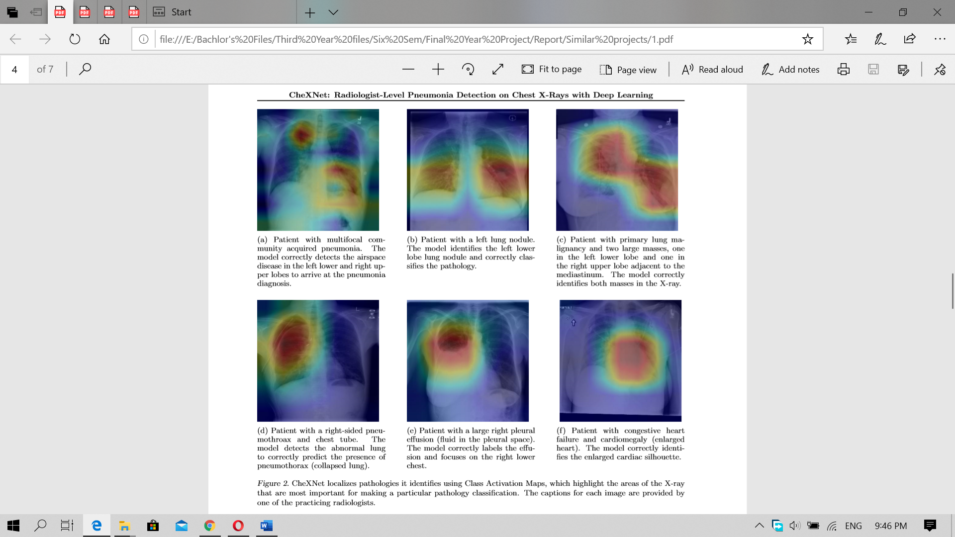

Figure 1 Class activation maps highlight area that are important for chest x ray analyzing

The research conducted had some of the major limitations as mentioned in the paper. Firstly, there were only frontal view of the x ray is provided to radiologist and algorithm where radiologist were a bit backward as in the real-time the lateral view of the x ray were also examined which shows up to 15% accurate diagnosis is done by seeing both of the view. None of the examiner i.e. model or radiologist were given the patients’ medical history which makes the radiologist performance decrease as most of the disease shows the symptoms and hence x -ray is done for the confirmation of the diseases. (Pranav Rajpurka, 2017)

The research paper concludes with the improvement in the field of the x-ray image analysis to the model that had already been developed i.e. ImageNet. Keeping the weight of its as it is the further improvement was done so the model could perform the outstanding performance in the image analysis beating the well experienced radiologist.

## 2.3) An efficient Deep learning Approach to pneumonia classification in healthcare

The article was published in the Hindawi Journal of Healthcare Engineering. The research paper proposed and developed by the researchers from the Dongseo University, south Korea**.** The research focus on the development of the convolutional neural network model from the scratch level unlike other research focused on improving the performance and accuracy of the already trained model in any of the form of the dataset. The research was conducted for providing the beneficiary for dealing with the medical imaginary. Several data argument algorithm was deployed for improving the validation and classification accuracy of the fully scratched model.

The research was conducted in the chest x-ray image dataset available on Kaggle. The dataset contains 5856 x-ray images of the pediatric patients. To balance the validation accuracy the original structure of the dataset folder train, test and validation was altered into two main folders i.e. training and testing folder where each contains 3,722 and 2,134 images respectively. (J.Melendez, 2015) The image preprocessing was done by using the different data arguments which helps to minimize the overfitting issues. The rescale includes the image magnification or reduction during the argument. The rotation shows the rotation of the image randomly into different ways during training process. The horizontal translation of the image was done by 0.2%, where shear range of 0.2% clips image into the counterclockwise direction. The random zooming of the image was done by 0.2% which the flipped the image horizontally. The below table shows the data preprocessing done in this research:

|  |  |
| --- | --- |
| Method Conducted | Applied setting |
| Rotation range | 40 |
| Width shift | 0.2 |
| Height shift | 0.2 |
| Shear range | 0.2 |
| Rescale | 1/255 |
| Horizontal flip | True |
| Zoom range | True |

The model was made from the scratch by the researchers. The proposed CNN consists of the two major part. The feature extractors and a classifier. The proposed architecture of the CNN model consists of the convolutional, max pooling and the classification layers bound together for making a model. The feature extractor layers consist of the conv3×3, 32; conv3×3, 64; conv3×3, 128; conv3×3, 128, having the max-pooling size 2×2 with the RELU activation function. The output was then assembled into the 2D mapping planes where the feature gained by the feature extraction layer is stored. The feature output of 198×198×32, 97×97×62, 46×64×128, and 21×21×128 sizes were obtained from the feature map from the convolutional layer and 99×99×32, 48×48×64, 23×23×128, and 10×10×128 sizes from the pooling layer. Finally, after applying the convolutional and poling operation the image size of 200×200×3 was produced which was ready for the classification. The classification layer is the artificial neural network and is the dense layer here. To fit the obtained image along with the abstracted feature from the previous layer the flattening was done so that the image is converted into the 1D plane. This process makes the one lengthy feature vector of the image which is then used for the final classification of the image. For this dense layer of 512 neurons were created using the dropout of 0.5 from randomly switching the neurons activation in the training process. Below figure shows the graphical structure of the model.

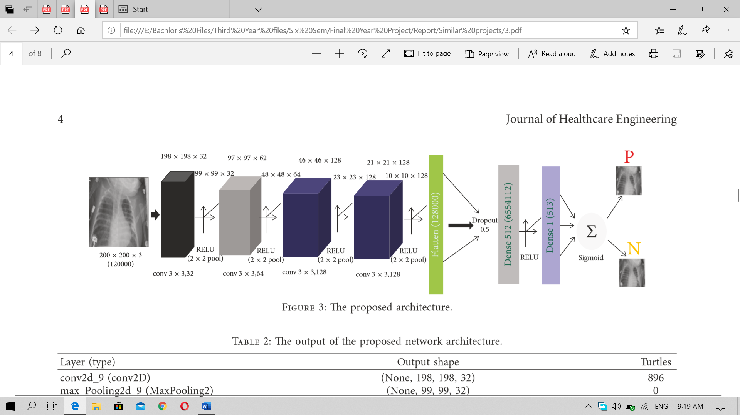

Figure 2: Proposed CNN Model

For the model evaluation the training was done for 10 times by conducting different hyperparameter changes like data argument or preprocessing, learning rate, annealing etc. to make the fitting of the smaller dataset easily into the CNN model. Which gives the better accuracy and classification. For testing purpose, the images were reshaped into 100×100×3, 150×150×3, 200×200×3, 250×250×3, and 300×300×3 sizes and were trained. The obtained model evaluation is shown in the below table.

|  |  |  |
| --- | --- | --- |
| Image size | Training accuracy | Validation accuracy |
| 100 | 0.9375 | 0.9226 |
| 150 | 0.9422 | 0.9343 |
| **200** | **0.9531** | **0.9373** |
| 250 | 0.9513 | 0.9297 |
| 300 | 0.9566 | 0.9301 |

Here, the model gives best accuracy in testing and validation phase in image having the size of 200×200×3. Although the accuracy varies as the image size the classification report wasn’t much changed. Here all the size was trained equally so the larger training time and computational cost could lead to change the performance in the larger image size. The performance of the 150×150×3 image is also like the 200×200×3 image. (Stephe, 2019)

The articles ended showing the best accuracy and validation result in the model that are being made from the scratch and performed several experiments for validating the result given by the model by training it on different sized image. It also suggests the extension of the model could be done for classification of other thoracic diseases like lung cancer.

## 2.4) Detecting Pneumonia in Chest X-rays with Supervised Learning

The research paper was published by the team of the researchers from the Stanford University. The paper focus in the utilization of the supervised learning and the deep learning process in the detection of the Pneumonia from the X- ray. As, the X ray could be used in detecting different kinds of the other Disease, the research is focused on selecting the pneumonia only from the x- ray. It also focuses in comparing the Logistic Regression algorithm with the Deep learning neural networks. Th research tried to find out whether the algorithms can detect exactly pneumonia from the dataset which also contains other diseases images also. The paper analyzes the models and algorithms and provides the suggestions of the future works that could be done for optimizing this works and continuing this works for even better diagnosis result.

As the research is focused on the detecting the pneumonia from the x ray dataset where other diseases are also presented the dataset used contains the huge numbers x ray with different kinds of the diseases. The dataset used was officially released by the NIH for the public use and is available in the Kaggle. It contains the 30,805 unique patients x rays and total 112,120 x-rays. The label in each x-ray were generated by using the NLP by mining disease classification from the associate radiological reports and it said to be 90% correct. The images presented in the dataset is to be classified as the binary classification i.e. weather the x-ray image contains pneumonia or not. This is one of the strong imbalances and challenging class in this dataset because only 1% of the images are expected to be labelled as the pneumonia. So, AUC was used for measuring the error metric rather than accuracy.

The dataset was resized to 32*32 resolution from 1024*1024 resolution for logistic regression purpose and 224*224 for using in the deep learning model. for classification of the pneumonia class the researches first use the clustering method for the classification method. The research team tried to make the two clusters as it is binary classification and tried to make the closure of the data that have the similar features. The first sept doesn’t make the clustering possible during the visualization purpose (shows in figure). Then the K- mean clustering was applied for making clustered of the data (shown in figure). By applying the K-mean clustering the two clusters were formed but the data was mixed into the two cluster. Then finally to separate the data from mixing into the cluster t-SNE was applied which separate the data into two cluster (shown in figure). Below is the sample from the two cluster after applying t-SNE.

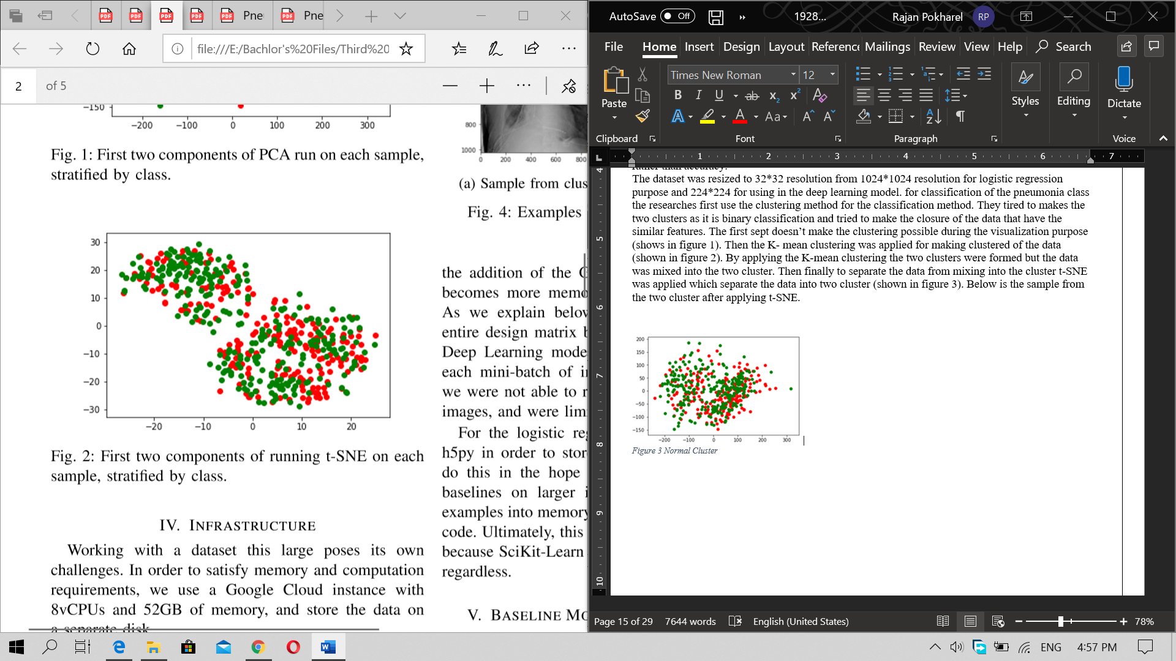

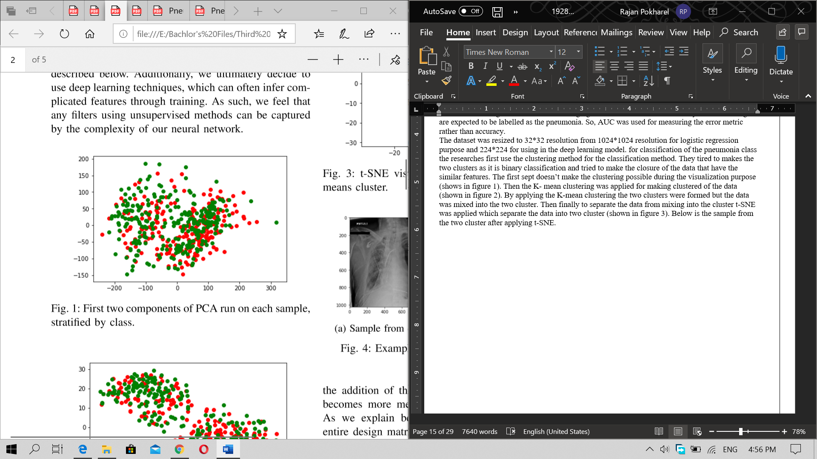

Figure 4 Normal Cluster

Figure 3 After Applying K mean

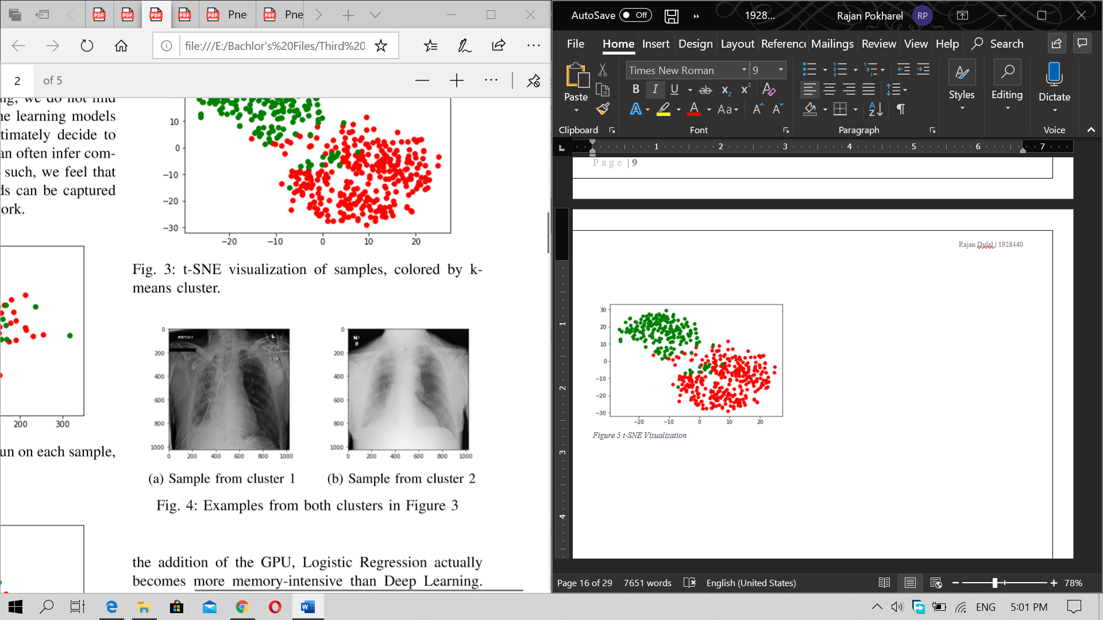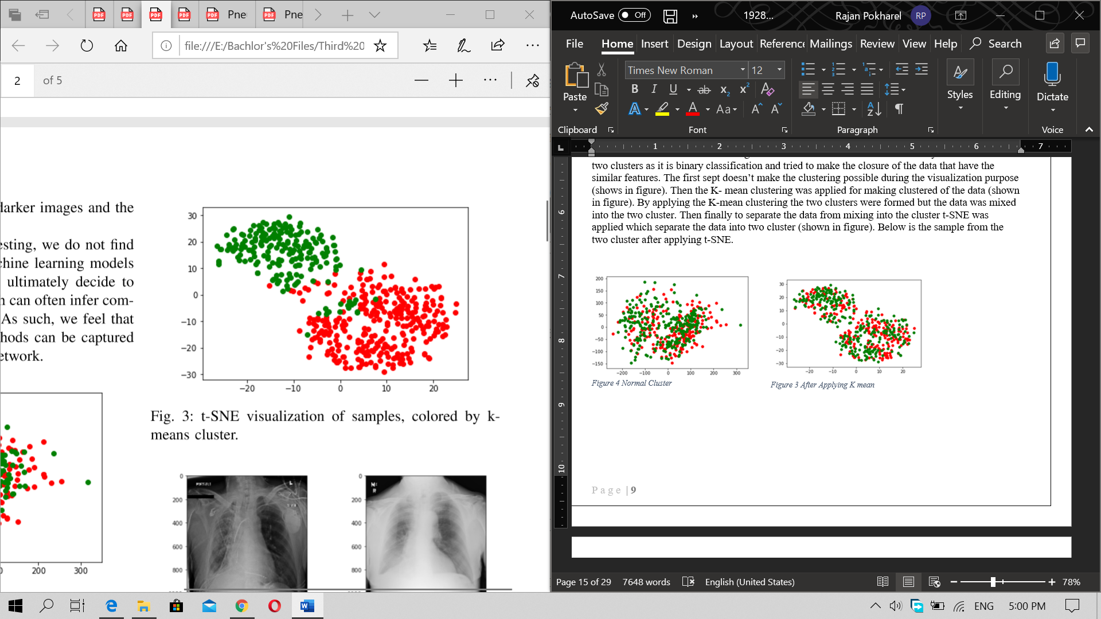

Figure 5 Sample from t-SNE visualization

Figure 6 t-SNE Visualization

Though the datas were sepretated into the two clusters it isnt well for classifcation of the pneumonia becaasue the cluster contains some other imaes that have the ame features that of pneumonia. So researchers conclude the deep leanring for classification of the pneumonia.

For the using the deep leanring the project uses the Google cloud with 8vCPUs and 52GB of memory, and store the data on a separate disk. For the deep learning section of the project, an NVIDIA P100 GPU was used. the SciKit-Learn, and PyTorch were implemented for the Deep Learning section of the project.

First logistics regression was used as the base model for th classificatio nbecasue it was easy for th implementation. Each pixel of the image was refered as the feature and a regularization was added into the loss function which gives the folowing loss function.

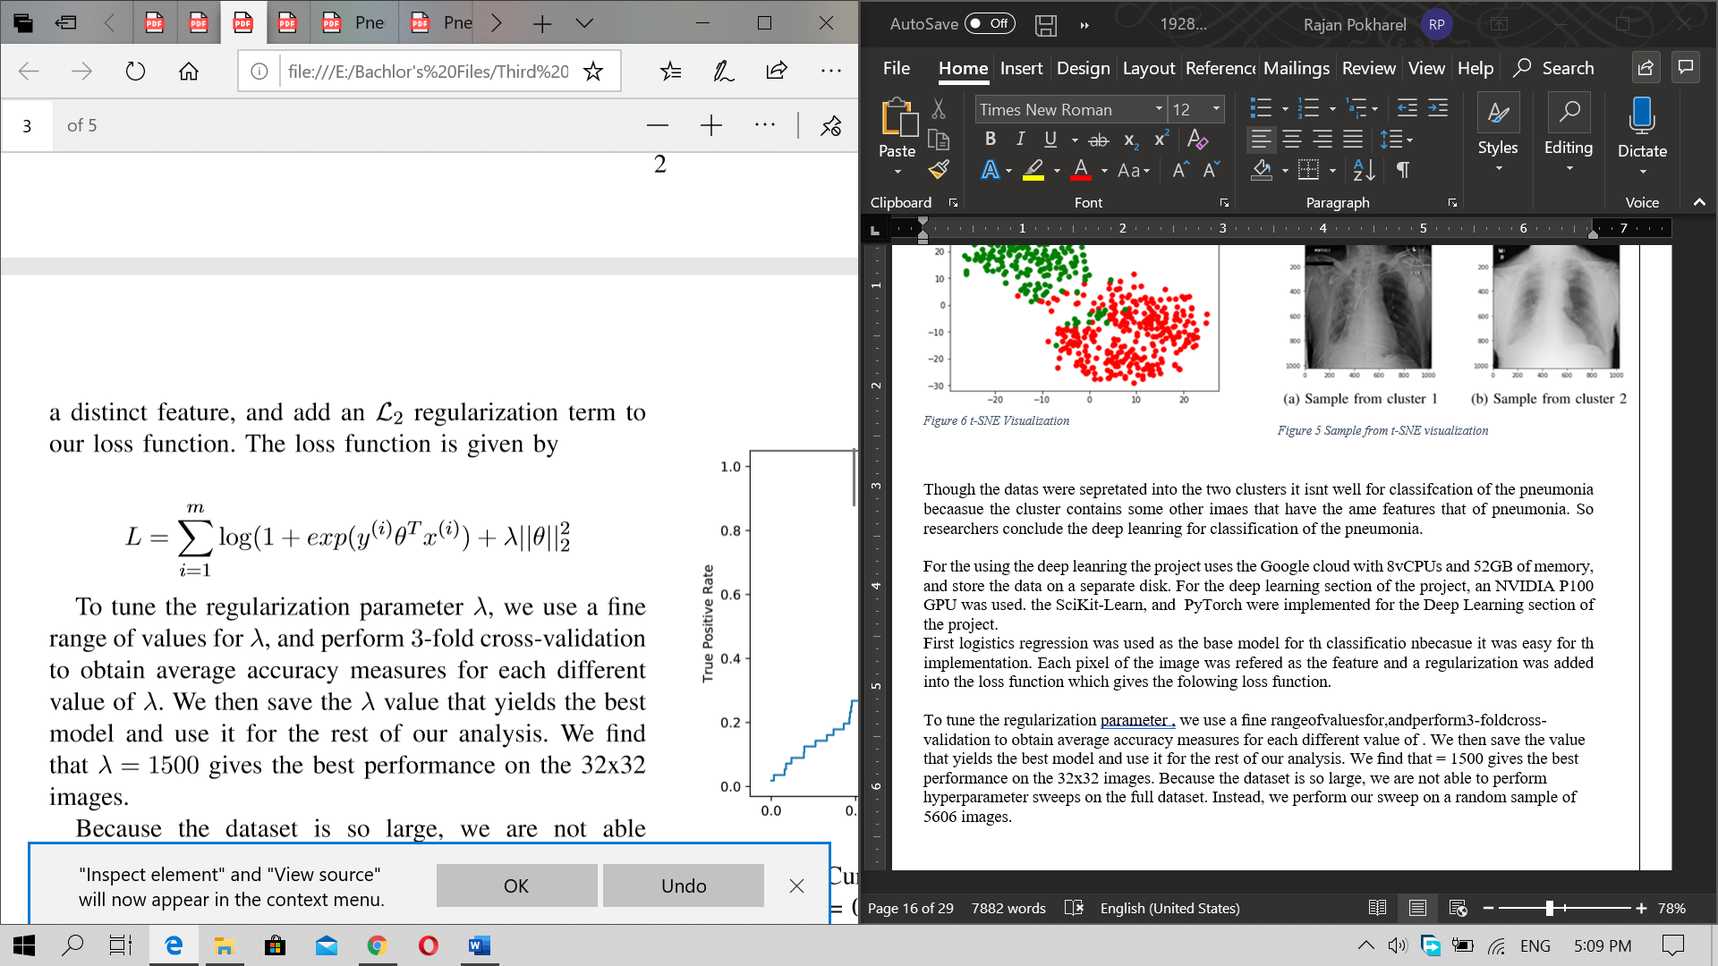

To tune the regularization parameter ʎ, ﬁne range of values for regularization parameter ʎ and 3-foldcross-validation for the regularization parameter ʎ was performed to obtain average accuracy measures for each different value of regularization parameter ʎ. Then the saved best value was used for the rest of the classification.

The best performance was achieved when the value of the ʎ was 1500 on the image size of 32*32. Due to the large dataset the hyperparameter was performed in random sample of 5606 images. Using the value of ʎ the logistic regression is applied into the entire dataset by splitting it into train, test and validation sets. After the training is completed the model as able to gives the AUC of 60% on the test images using the image size 32*32. The regression model was also loaded into the dataset which have the image size of 128*128. The AUC obtained is lower than the previous model i.e. about 58 percent. The model was unable to provide the large percentage of the AUC because of the regularization parameter that is tuned for smaller images. The regression model could perform better result if the parameter could be made higher. But making parameter higher required more amount of the computational power because the large matrix and SciKit-learn’s high memory requirement. Though the regression model gets the AOC of 0.6 percent the pixel feature and the edge detection features could gives even better result. The researchers then turned towards the Convolutional Neural Network.

For the deep learning the researchers use the already made model CheXNet which uses the 121-layer dense CNN. The model was used for the transfer learning using the PyTorch. The weight of the model was trained on the ImageNet dataset. The model was altered with the custom-made output SoftMax layer. The image was then rescaled into 224*224 for training in the model. Adam was used as the optimizer for the model. Where binary cross-entropy loss as the loss function. After training the model the model was able to gives the AOC of 0.609 which is only slightly better than the logistic regression. Though the document of the CheXNet shows the achievement of the AOC of 0.828, here the researchers couldn’t achieve near to it. This is believed due to the greater number of the non-pneumonia images than the pneumonia in the dataset. Also suspected that the loss function was optimized but the featured learned on the training set isn’t generalized in the validation set. (Antin, 2017)

The research paper was concluded by providing some of the future works that could be used for improving this research. Like improving the logistic regression model, error analysis in the Dense net, for the better extraction of the certain disease or the classes from the huge number of the classes present in the dataset.

## 2.5) Deep Learning Approach for prediction of pneumonia

The research was published in the International journal of scientific and technology research. The research was focused on the utilization of data argumentation, residual networks and stochastic gradient for the achievement of the maximum accuracy in the image segmentation.

This research uses the dataset from the Kaggle containing the 5863 images of the patients containing the class pneumonia and non pneumonia spitted into the folder of train, test and validation. The data argumentation was done before using the dataset in the model. For which the images were generated randomly to avoid the overfitting problem in the model. In order to perform this random lighting transformation was done with the white balance of 0 and contrast of 10.the model was prepared by using the existing ResNet34. The dropout was set to 0.6 for managing the overfitting problem. The model was trained using the smaller image size at first i.e. of 64 then gradually increased the size of the model.

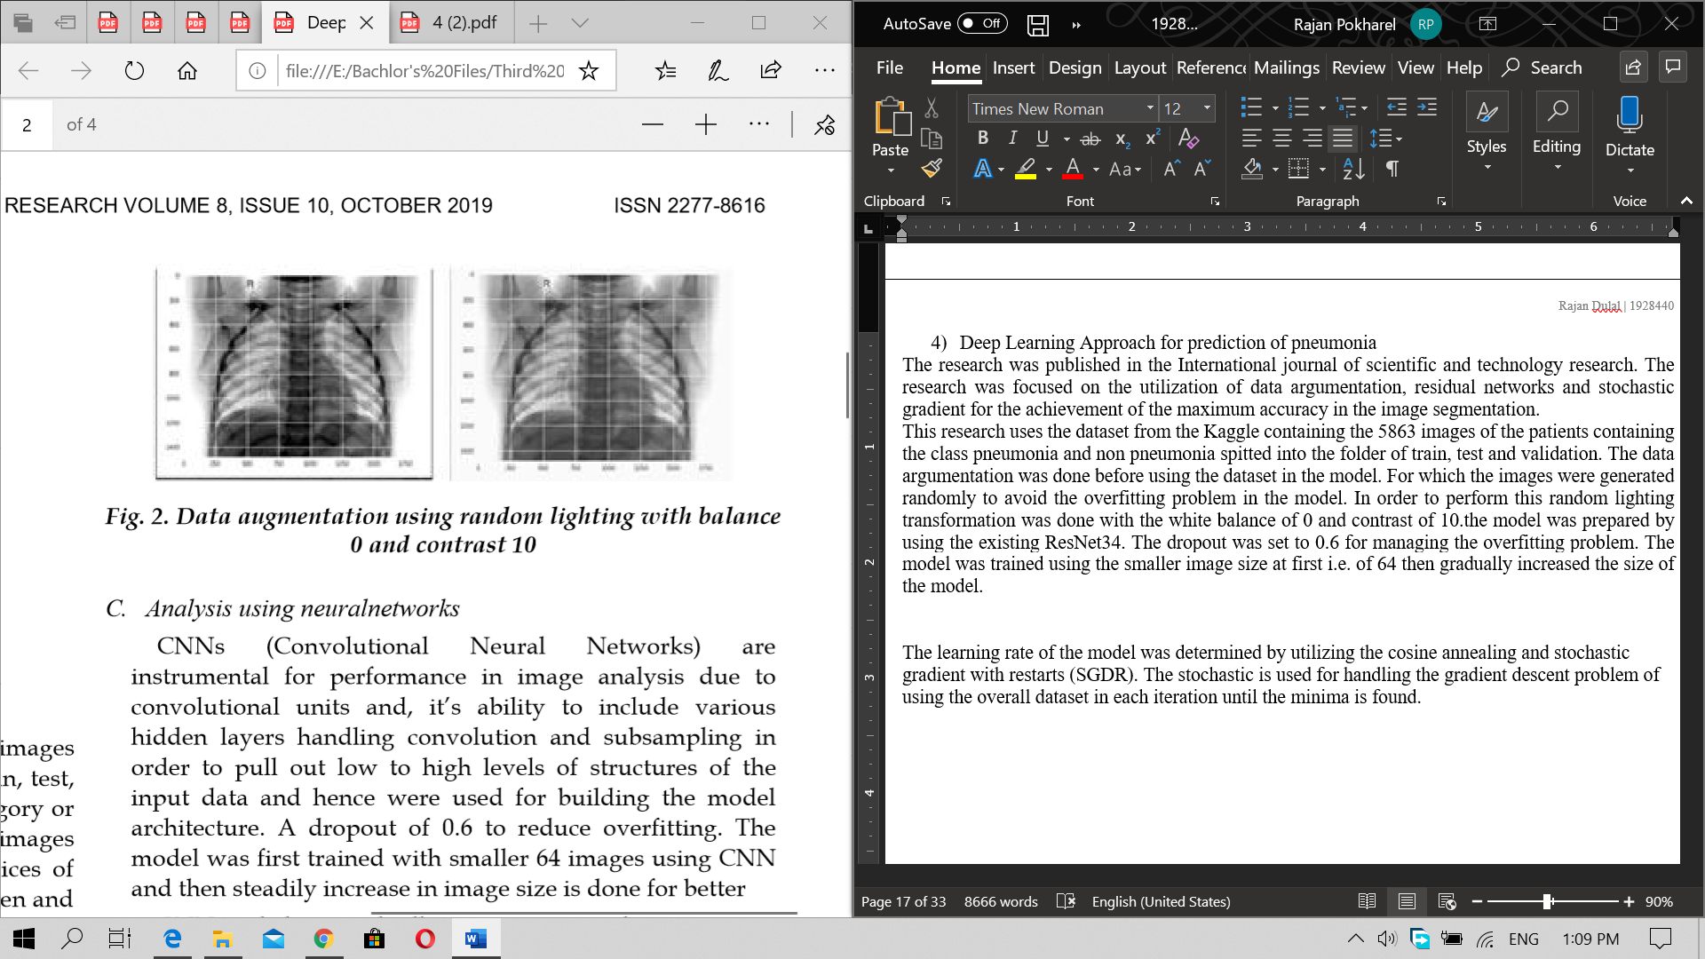

Figure 7 Data Argument using random lighting

The learning rate of the model was determined by utilizing the cosine annealing and stochastic gradient with restarts (SGDR). The stochastic is used for handling the gradient descent problem of using the overall dataset in each iteration until the minima is found. The model was trained using the different learning rates. For determining the learning rates the graphs of loss versus learning was plotted. During the training the mode might got stuck in local minima instead of approaching the step towards the global minima. To avoid this SGDR was used in the model. This helps the model to finds its way towards global minima.to void model getting stocked the learning rate value was retuned to original as a parameter then reduced over the epoch as described in the cosine handling. To check the learning rates of the model first it was kept as low as possible then gradually increased after each process is completed. The model was trained in three learning rates i.e. 1e-4, 1e-3, 1e-2 for up to 500 epochs. The model was also trained using the image size of 128*128, 256*256 and512*512. The training loss was observed to be same as of the validation loss which suggest the model was good at categorizing the images. (Kadam, 2019)

After training the model for 500 epoch the test accuracy of the model was 92.9% having the precision and recall of 0.9088 and 0.997 respectively. The model weight was saved and was used further for classification of the x-ray images. The multilevel thresholding is applied for images for segmentation using the Otsu thresholding which keeps clusters tight and maximize the separation between cluster at the same time.

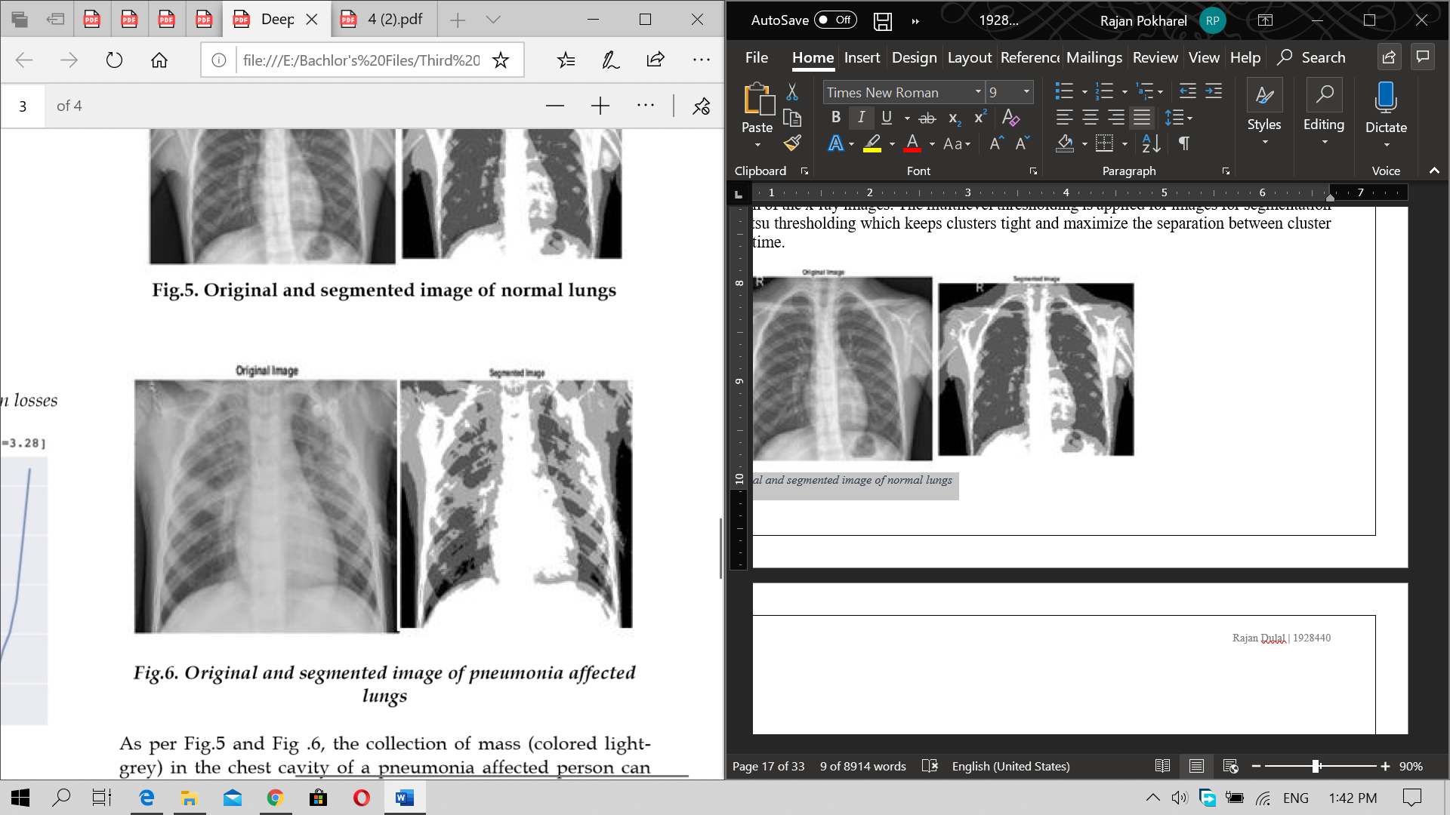

Figure 8 Original and segmented image of pneumonia lungs

The research paper was concluded by providing the limitation of the model built like the problem in fast processing by the processors, accuracy level of 100%, noise in the medical images due to the sensors etc. The research suggests the use of the Otsu thresholding for the segmentation of the images.

## 2.6) Detecting Pneumonia with Convolutional Neural Networks

The research was conducted by the team of the University of North Carolina. The research uses the CNN for the pneumonia classification using the dataset of 26000 training images and 3000 testing images. The training set have the 6000 images as pneumonia and 20000 with other lungs diseases. The dataset contains the images into the DICOM format which was transferred into the PNG format. The images were also reduced into the resolution of 128*128 for easy processing. This image dataset was used in the first model i.e. model 1. Another dataset of CSV format which have the class attribute of “lungs opacity”, “no lungs opacity/not normal”, “no lungs opacity” is indicated. This shows weather the patient has pneumonia, other diseases or completely normal. Further the dataset was separated into only two classes of “no lung opacity” as healthy patients and “Lungs opacity” as unhealthy patients. This dataset was used in developing the model 2a and 2b subsequently.

For the development of the model the researchers use the sequential CNN for creating the model. The images were resized into 128*128-pixel values. Keras library as used with TensorFlow as the backend. The images were then passed into the Keras as the RGB files which was handled by the Kera’s Conv2D.The max pooling was used for getting the maximum pixel value of the desired areas. The flattened layer was created using the Kera’s flatten and kera’s dense to connect the layers. The sigmoid was used as the activation function for the binary classification and binary cross entropy was used as the loss function.



Figure 9 Proposed CNN model by researchers

For the model evaluation the researchers use two different ways. First the model was used for classifying the pneumonia and non-pneumonia. Then the model was divided into three part where first was used for classifying images with opacity. Which was named as 2a. then model was used for differentiating between opacity and pneumonia and finally with opacity and no pneumonia but other lungs diseases which was called as the 2b. Researcher also uses the 2a images prediction as the opacity to the 2b model as the input images. The model 1 gives the accuracy of the 78.5%, model 2a gives the accuracy of 68% whereas the model 2b gives the accuracy of 69 %. Following figure shows the Accuracy, Sensitivity (TPR), Speciﬁcity (TNR), Positive Predictive Value (PPV) and Negative Predictive Value (NPV) for all the three models made.

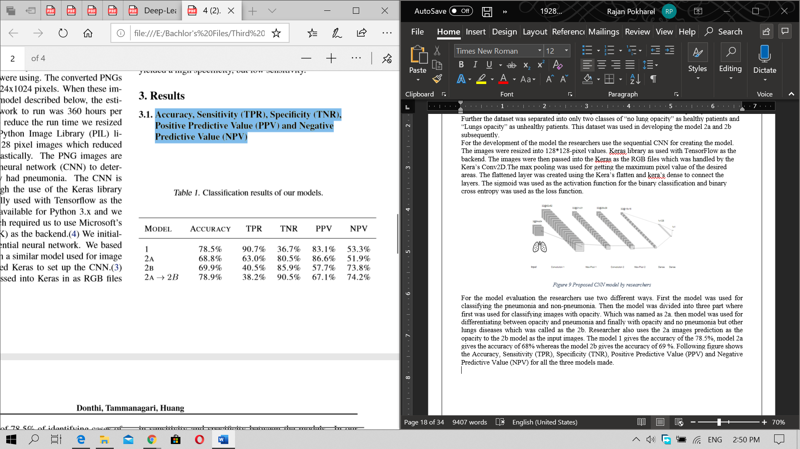

Figure 10 Classification result of the model

Though the accuracy of the all the model were same the sensitivity and specificity varied. Model 1 have the high accuracy and low specificity which means the model can classify the pneumonia in the abnormalities more accurately. The model 2a was able to exactly classify abnormal as abnormal as was also better as correctly classifying the normal as normal. Model 2b couldn’t correctly classify the abnormal from the pneumonia but was able to classify the pneumonia from the abnormal CXRs. (AbhayDonthi, n.d.)

In conclusion the model was unable to extract the features for classifying the images correctly. The research paper also suggests using the higher resolution of the images for the correct feature abstraction. Overall the researcher suggests using the model 1 for clinical evaluation of the CXRs for the easiness of the diagnosing person but under the supervision of the experts.

## 2.7) Comparison between the research conducted

|  |  |  |  |  |  |
| --- | --- | --- | --- | --- | --- |
| Projects | Dataset used | Data Preprocessing | Deep learning structure | Accuracy | Conclusion |
| CheXNet: Radiologist-Level Pneumonia Detection on the chest x-rays with deep learning | 112,120 frontal view of X-ray of 30,805 different patients | Resized into 224*224, randomly flipped into horizontal | Trained on pretrained ImageNet model with final layer replacement for binary classification | 76% | Can perform accurately in the seen data with scoring higher than the professional radiologist |
| An efficient Deep learning Approach to pneumonia classification in healthcare | 5856 x-ray images of the pediatric patients | Resized into 225*225, rotation 40 degree along with the horizontal flip | Developed from scratch.  extractor layers consist of the conv3×3, 32; conv3×3, 64; conv3×3, 128; conv3×3, 128 layers | 93% | Indicates that best accuracy could be gained by implementing the deep learning layer from scratch by knowing the exact feature that are to be abstracted from the image. |
| Detecting Pneumonia in Chest X-rays with Supervised Learning | 112,120 x-rays by NIH | Resized into 32*32 and 224*224 and trained separately | Uses the CheXNet model for training the dataset | 0.609 AOC | Model trained for two classes classification cannot gives desired accuracy while trained in more than two classes in another dataset |
| Deep Learning Approach for prediction of pneumonia | 5863 images of the patients | Resized into 128*128, 256*256 and 512*512 and trained separately | Uses the pretrained ResNet34 along with the modification of the last layer | 92.9% | Different learning rates, training epochs and resizing images varies the accuracy and overall performance of the model |
| Detecting Pneumonia with Convolutional Neural Networks | 29000 images of x-rays | Resized into 128*128 no other transformation was done | Two normal Convolutional layers were used | 78% | Higher resolution images with high performing computational power could gives the best feature abstraction result in CNN |

In the above table all the project had done well so far in the classification of the pneumonia and non-pneumonia. Some had tried to classify the pneumonia particularly from the different set of the diseases labeled in the dataset. The overall goal of the projects was to classify the pneumonia so the best pneumonia categorization is done by the research article name “An efficient Deep learning Approach to pneumonia classification in healthcare” it had achieved the accuracy of 93% which had also beat the accuracy of CheXNet which was claimed to beat the radiologist in the pneumonia detection. Although the research paper hasn’t mentioned about forwarding the project against radiologist for detecting the pneumonia is could significantly perform well. The least accurate CheXNet claims to beat radiologist in detecting pneumonia but when the same algorithms were tried to replicate by another research team in the research paper “Detecting Pneumonia in Chest X-rays with Supervised Learning ” the claimed accuracy isn’t achieved this might be from the wrong data preprocessing.

Though there are many limitations in performing the projects like preprocessing difficulties, accurate dataset, computational power the future towards medical image segmentation is moving rapidly which had provides huge facilities for the health works in analyzing the images and predicting the disease in the patients.

# Supportive information/ Theory foundation

The system uses the machine leaning method for the image classification. It uses the deep learning approach for the image classification where the neural network is used for the training of the model. The neural networks are the network of the neurons which have the input activation function and the output (Kang, 2017). The Convolutional neural network is widely used in image classification due to its capabilities of feature abstraction from the images. (Saha, 2018) It makes much more accurate edge detection and feature abstraction. It has the pooling layer, CNN layer and flatten layers on it.

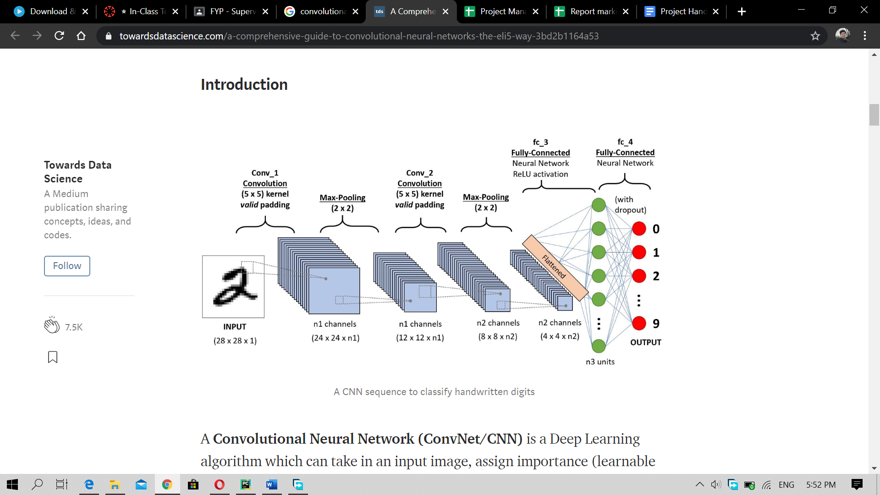

Figure 11 Convolution Neural Network

The model built in this project is by using the existing VGG 19 model that is trained on over million images. This is done for making the prediction and the feature abstraction of the model more precisely. To build the model the images is being preprocessed in order to achieve the details and the features of the images properly. Preprocessing includes the resize, rotation, flipping, rotation etc. of the images. (Pandey, 2019)After processing the image, the images are then used into the model in order to train the model.

After training the model the model is evaluated by the confusion matrix derived by the model. It shows the total number of the image having the actual label against the total number of the image predicted by them model for both classes. (Narkhede, 2018) Here the confusion matrix is compared between the two model for analyzing the performance and the classification strength of the model.

The model performance is also evaluated by the Precision and recall derived during the model development. Precision is the total number of the true positive (Actual pneumonia) divided by the total number of the true positive (Actual pneumonia) and false positive (normal incorrectly labeled as pneumonia). (saxena, 2018)Below is the formula for precision calculation.

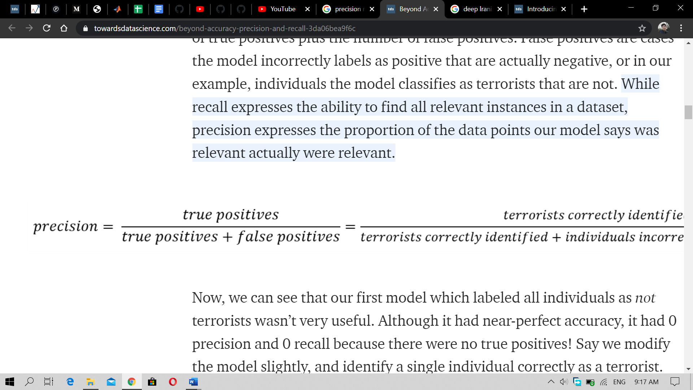

This shows how precisely model classify the images along with how correctly the model classify the images to their respected classes. Recall is calculated by dividing the total number of the true positive (Actual Pneumonia) by the sum of true positive (Actual Pneumonia) and false negative (pneumonia incorrectly labeled as Normal). (Koehrsen, 2018) The formula calculating the recall is shown below.

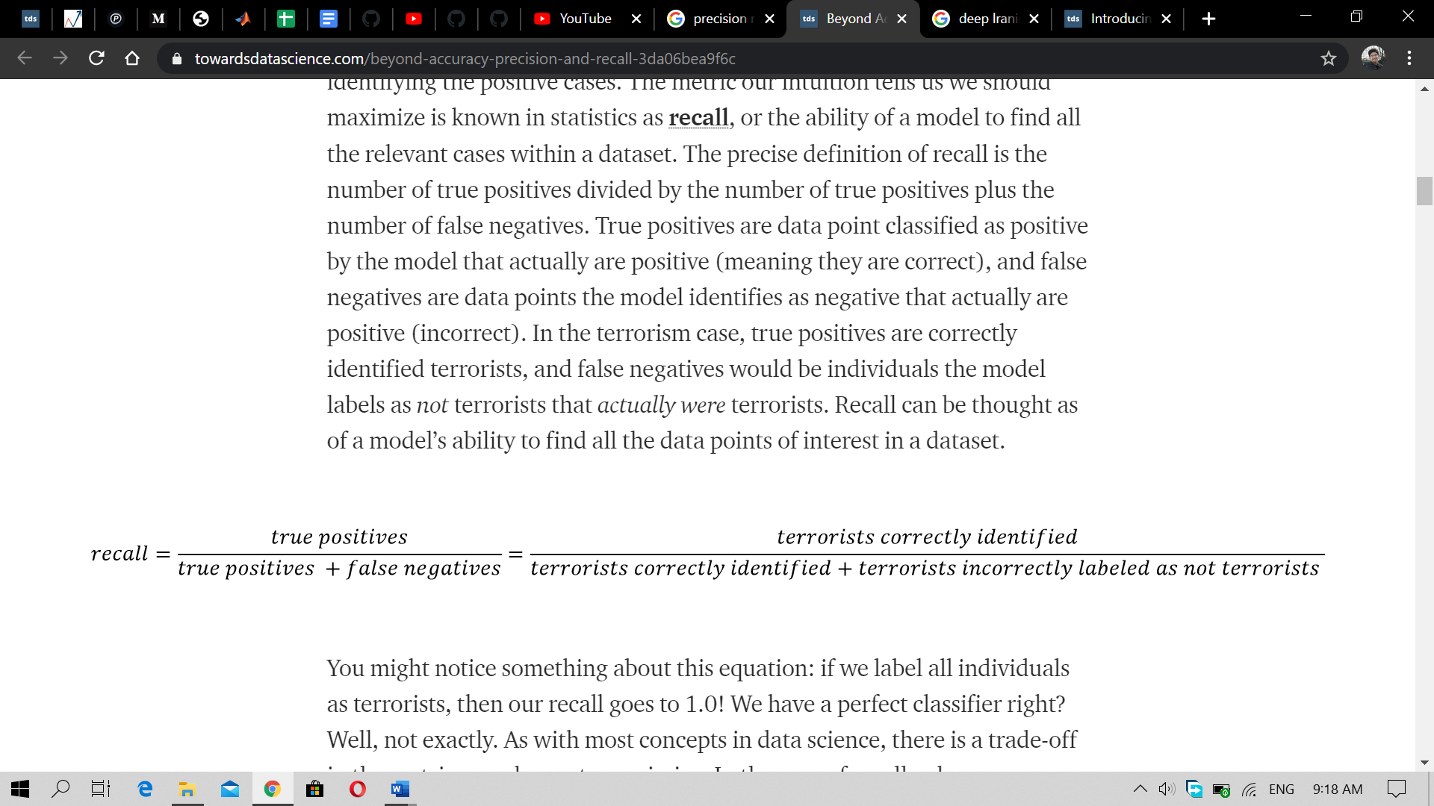

The accuracy of the model is also used for model differentiation which means the accuracy model achieved during the training process while matching the testing image with the validation images.

# Main details and development about artifact produced

This project aims to produce two main artifacts. The machine learning model which will analyze the medical image i.e. X-ray of the patient and the web application which provides the interface for the user to upload the picture of the X-ray and the prediction is done in the web application. The project features the following two artifacts:

1. Web application
2. Machine learning Model

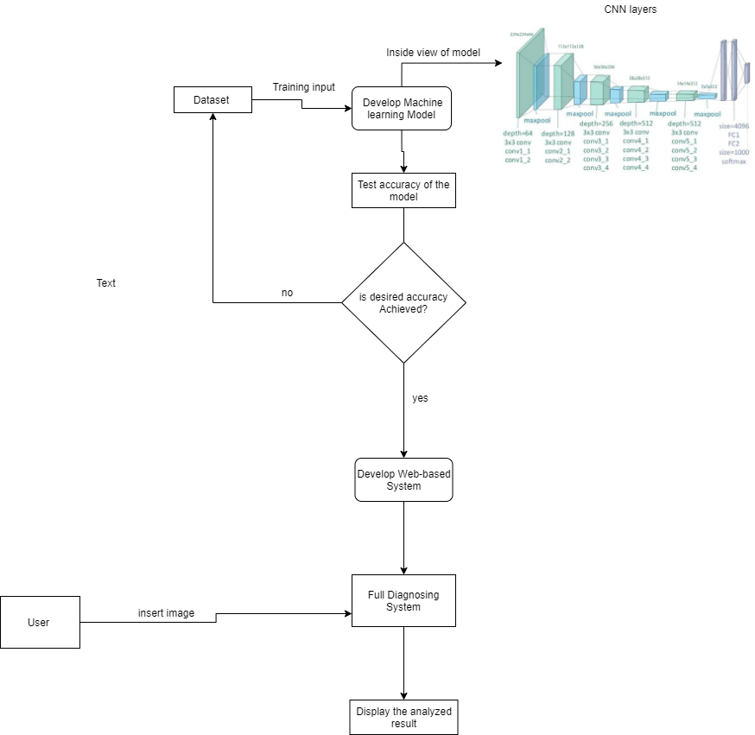

Figure 12 Pipeline for the project development

The above figure shows the pipeline for the project development. The dataset is chosen which is trained in the developed model which is made by customizing the VGG 19 ImageNet weight. The model measured according to its accuracy, until the desired accuracy is met the model was trained. After training the model the development of the web-based application is performed. This application gives user friendly environment for the user to upload the image and analyze it and display result in the same web page.

## 4.1) Methodology used

Waterfall methodology is used during the project. The number of requirements for the project is fixed i.e. to make web base system which could detect the pneumonia of the x-ray images. Agile methodology is also used for the project but due to the group focused methodology it might is not suitable for this project. Although some feature of scrum of agile methodology like making product backlog, sprint could be inherited in project but due to difficulty in modelling the AI the module delivery within the sprint isn’t possible in the worst-case scenario. (Sacolick, 2020)

One the other hand waterfall methodology let us develop the system by one by one completing each module in time. As there is chance of failure in steps during the development the process which leads the process to be repetitive (Lotz, 2018).When the machine learning model didn’t give the accuracy as expected then the development process is taken to reverse, where the development of algorithm is done completely from the scratch and the whole process is again started from the beginning. Due to the tedious process of repetitive task should be done the waterfall methodology is chosen for the project and which ultimately is successful during the project time.

## 4.2) Tools used

* 1. Visual Studio for code editing and project structure management

It is the easiest tool to use and have lots of extension which helps in the project no matter which language is used. It also provides the well facilities for the project management and structuring the project. The web application is made using the visual studio in this project.

* 1. Jupyter Notebook for machine learning code execution

Jupyter notebook is provided with the Anaconda which is the popular machine learning tool used for creating the models and editing the codes. It runs on the local host in the browser. It directly runs the code line by line and display the output. It is used for creation of the model, data preprocessing and hyper parameter tuning purpose.

* 1. Google Collaboratory lab

Google Collaboratory lab is used exclusively for the model training purpose. Due to the need of the high-end GPU colab is used for training the model in this project. It is one of the fast and efficient platforms for executing the machine learning code. It also provides the facilities like built in install of all the libraries needed for the machine learning development.

* 1. Dataset for training and testing the model

Dataset is used for training the model. The dataset using in this project is from Kaggle where there are more than 5800 images separated differently for training and testing purpose for the model. The dataset has different folders containing the training, testing and validation of the data.

d) Version control and backup software

GitHub is used as the version control and backup software. Due to the used of the google Collaboratory the google drive is also used for the backup and the storage of the model as well as the dataset.

* 1. Language used:

Python is used as the main language during the whole project execution period. As, python supports most of the machine learning library easily it is easy for importing and implementing different kinds of the libraries in the python.

* 1. Framework used:

Flask framework is used for the development of the web application. It is light weight and do not need to install library and have another specific requirement.

# Detail description about the development of the artifacts.

## 5.1) Web application

The web application is simple user interface designed for the users to make the image classification more easier and user friendly. The web application is the web page running in the local host device which have the webpage. The web page consists of the graphical interface or the image for the attraction. Following are the steps taken for the development of the system:

5.1.1) Requirement Analysis:

Different kinds of the requirement analysis are done in the very beginning of the development of the project. The project is based on the artificial intelligence so first the research is conducted in the AI part. Different Dataset is selected in order to develop the model. Different research papers were used as a reference for the model development. Gathering the dataset, previously developed models, analyzing techniques knowledge was done in the requirement analysis segment.

Following Software Requirement Specification Document provides the details of the functional and nonfunctional requirement of the system.

5.1.1.1) System Requirement Specification Document

This SRS is made for showing the requirement for the system build for analyzing the medical image. It is the documentation view of the system which analyze the x-ray image uploaded by the user. It serves as the solution for the tedious and the complex analysis of the x-ray. The SRS document consists of the user requirements, functional and nonfunctional requirements and other requirement that are gather during the requirement gathering processes. For detail SRS please refer to the appendix part of the report.

### 5.1.2) System Design

This section has the system design patterns the documentation view of the system. It contains the UML diagrams of the system which shows the view of the system and the overall uses of each component of the system. Following are the UML diagrams of the system which shows the overall system design.

5.1.2.1) Block Diagram:

This diagram shows the overall design idea of the system.

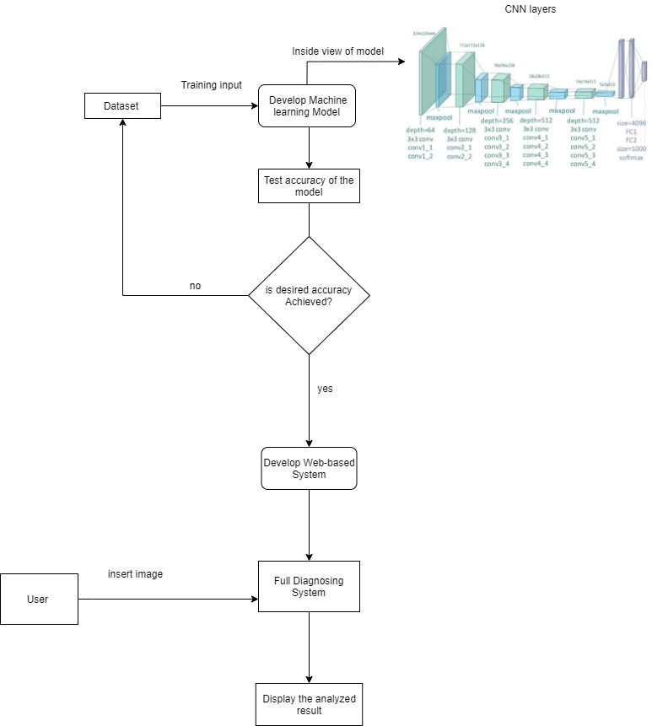

5.1.2.2) Activity Diagram:

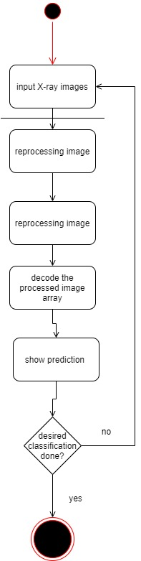

5.1.2.3) Sequence Diagram:

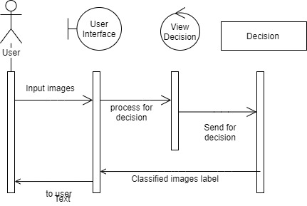

5.1.2.4) Use case Diagram:

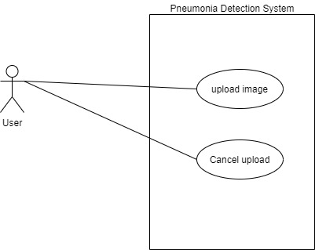

### 5.1.3) System Development:

After collecting all the requirements and prepared the system design the system as made. The web application is made using the flask framework of the python. It contains the machine learning model in the .H5 format which is used for the prediction of the images. The images are converted into the array values. The arrays values are decoded using the Keras decoder which helps to match the array value with the model so that the model could return the prediction of the image.

The details of the model development process are given in the section below.

5.1.4) Testing:

## 5.2) Machine learning model

The project was initially made using the own machine learning model which have custom made model structures and parameters used. Due to the unsatisfactory result of the prediction and feature abstraction done by the model the model development is shifted to tuning the existing model’s weight according to our need. The model is then made by using the existing VGG 19 model architecture’s weight and fine tuning it for classification of our images. The VGG 19 was developed in the ImageNet challenge for the classification of the 1000 classes of the images and was trained in 1 million image datasets. Due to trained on a greater number of images the model has strong capacity to abstract the feature even more precisely from our images which makes the computational efficiency for training the dataset in the model.

### 5.2.1) Data understanding

The dataset used in this project is from the Kaggle which contains the 5800 images of the frontal X-Ray of the patients suffering from the pneumonia. This contains the training folder, testing folder and validation folder. Each of the folder contains the sub folder Normal and Pneumonia which contains the images related to the specific folder name. Chest X-ray images (anterior-posterior) were the images of pediatric patients of 1 to 5 years from Guangzhou Women and Children's Medical Center, Guangzhou. Following is the structure of the dataset along with the sample images of the dataset.

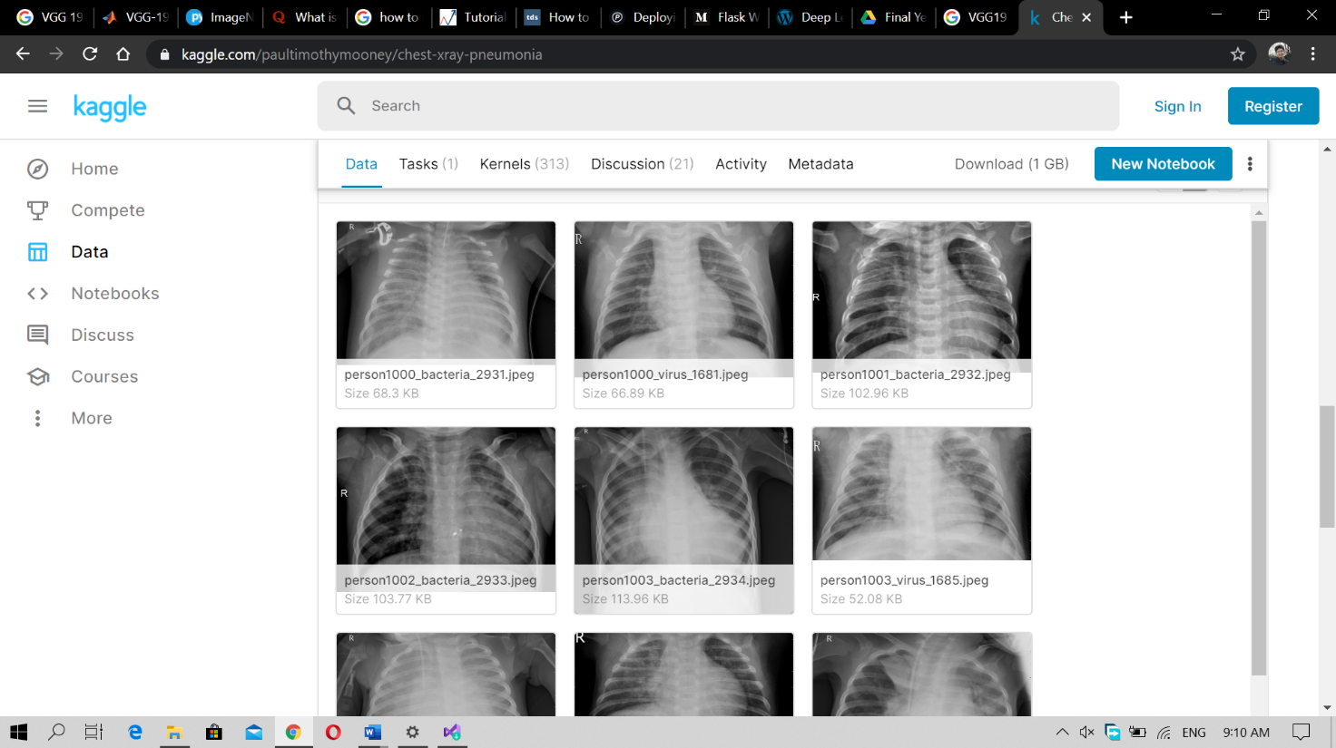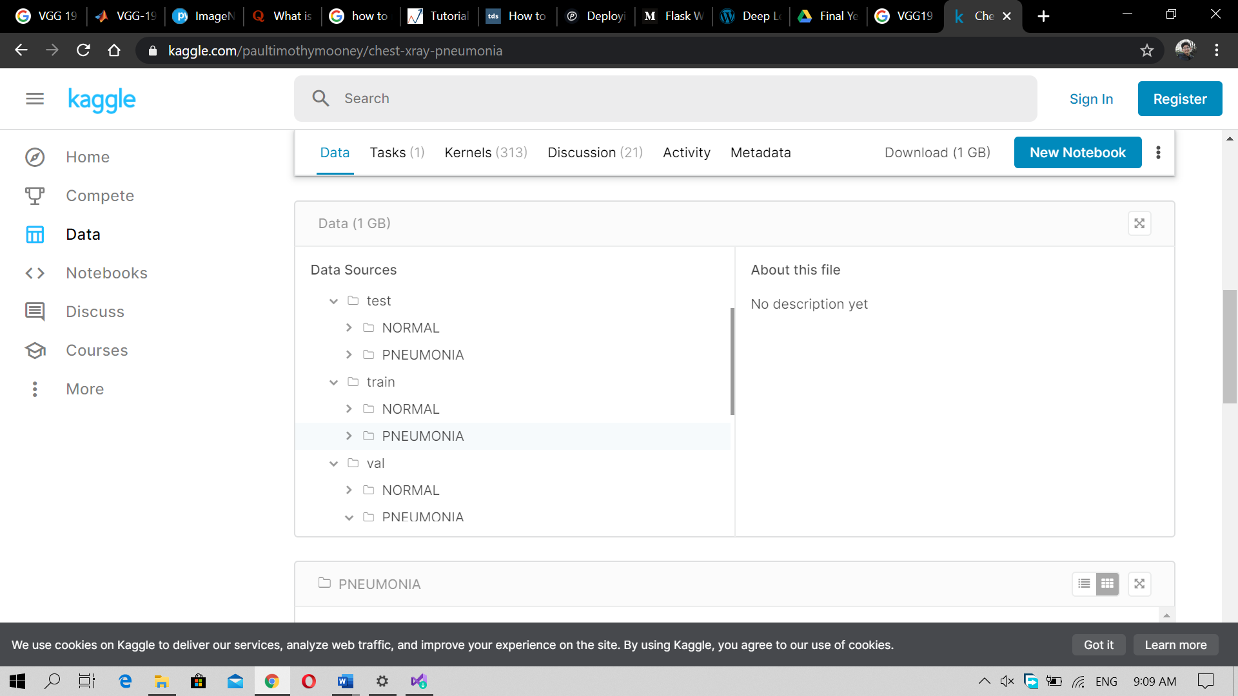

Figure 13 Sample of X-Ray from dataset

Figure 14 Dataset Structure

### 5.2.2) Data Preprocessing

Before the dataset is used for training purpose, certain preprocessing is done. The preprocessed data gives more flexible to the model during the feature abstraction period. The model is made using the ImageNet weight which represent the RGB images but the data which is used in this project is black and white, so the ImageNet images are set to the value of -1(black) and 1 (white) which is defined by making the X-ray function. For the preparation of the dataset following preprocessing is done.

|  |  |
| --- | --- |
| Preprocessing method | Value |
| rotation_range | 20 |
| height_shift_range | 0.15 |
| zoom_range | 0.15 |
| fill_mode | 'nearest |
| width_shift_range | 0.15 |
| shear_range | 0.15 |
| horizontal_flip | True |

### 5.2.3) Exploring Data Analysis

The dataset contains the maximum number of the pneumonia images. The normal images are comparatively less in number. Below graphs shows the number of the images presented in the each of the training classes. Due to the greater number of the images presented in the pneumonia during the training, the model is going to be biased and learn to detect pneumonia more in the prediction part. So, to overcome the overfitting problem during the training purpose the pneumonia images were made equal to the number of the normal images.

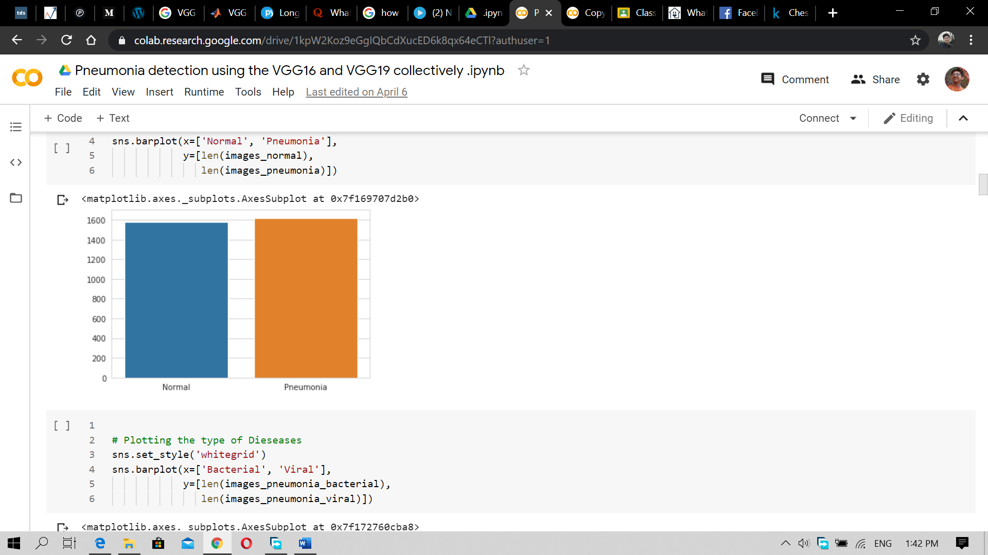

Figure 15 manipulated dataset

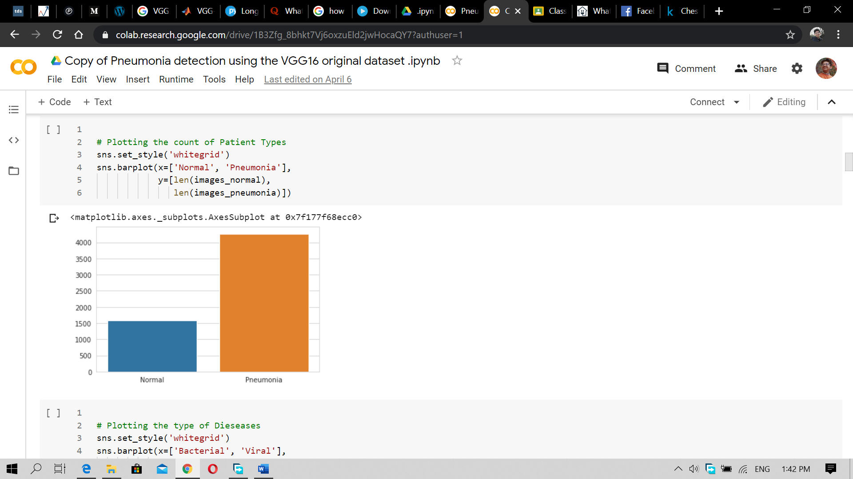

Figure 16 Original Dataset

After the equal distribution of the dataset is made then the process begins forward by plotting the sample images from each of the class by applying certain filters to the images. Following are some of the sample images presented in the normal and pneumonia classes.

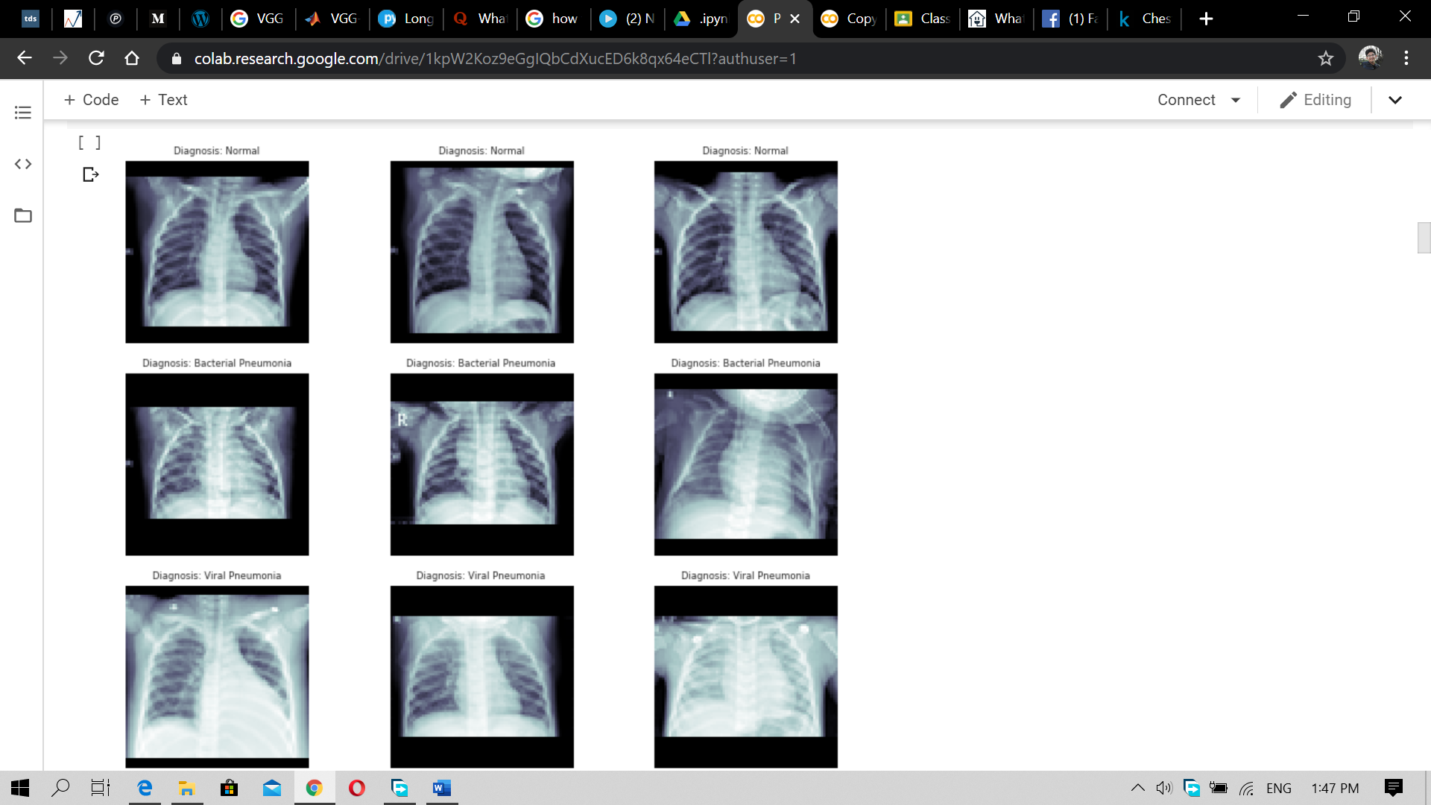

Figure 17 Sample Normal image



Figure 18 Sample Pneumonia images

### 5.2.4) Predictive Modelling

The model developemt is done by using the existing weight of the VGG 19 imagenet which had been already trainedin over million dataset. The base model is the imaget model of VGG 19 which is being devloped in the oxford university. Below is the pictorial representation of the base model along with the model summery.



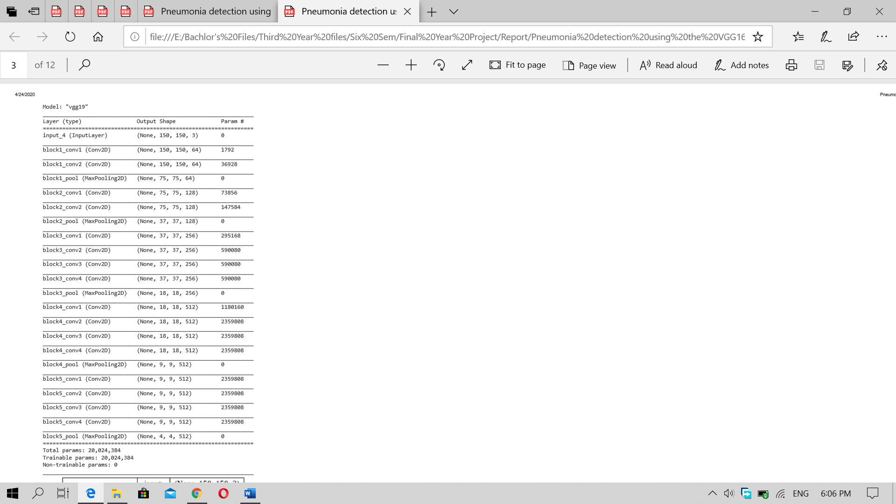

Figure 19 VGG 19

The model uses the 3*3 filter and the filter increases by the power of two like 64,128,256 etc. the padding is done by the one pixel. The convolutional layer uses the stride of the 1 pixel and the padding of the 1 pixel. There are main 5 set of the convolutional layers which contains other conv layer into them. The max pooling function separate the conv layers. The max pooling uses the 2*2 filter with the pixel value of 2 pixel. There are set of the conv layers with separate filter and parameter. 2 of them have 64 filters, next 2 conv layers with 128 filters, where next 4 conv layers with 256 filters, and next 2 sets have 4 conv layers each with 512 filters on it. The last pooling layer is flattened by making the connection to the next layer containing the 4095 neurons on it. The output produced from the previous layer is then connected to the last output layer containing the 1000 neurons which implies the Relu activation function. Finally, there is SoftMax layer which is used for producing the output for categorizing the 1000 classes of the images.

In this project the last layer of the VGG 19 is made changed with the custom-made layer which would be used for categorizing the X-ray image into two classes. The last layer is cut down and the new layer is implemented which have the following details. The drop out is set to 0.5 to the neurons that are being connected from that is connected to the flattened layer. With the pooling applying of filter 2*2 again and padding of 1 pixel the layer is connected to the dense layer which have the 128 neurons on it and uses the Relu activation function. Then the layer is connected to the final dense layer which have the 2 neurons on it for classification and uses the sigmoid activation function. After applying the changes in the base model, the model x1 is made. The model summery is given below:

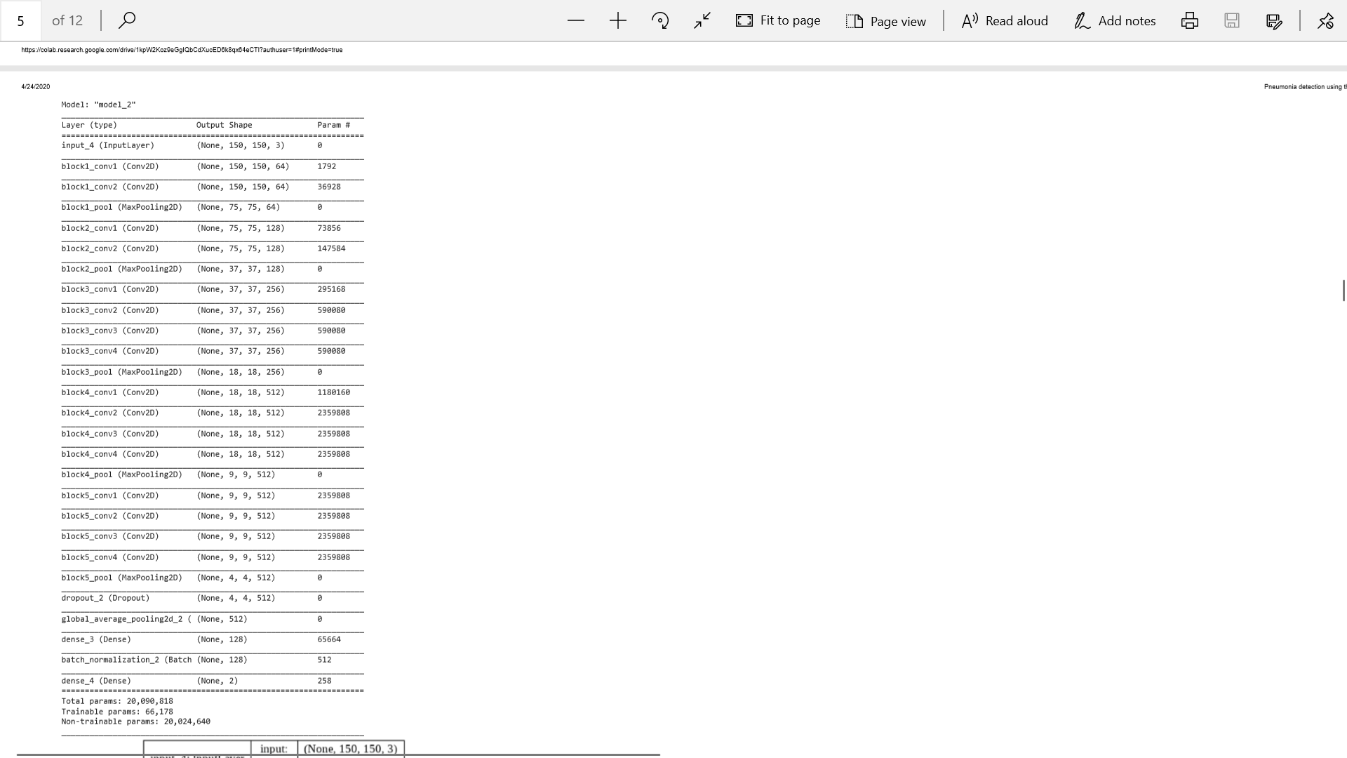

Figure 20 Customized x1 model

After performing the customization in the model, the model is ready for the training purpose. Adam is set as the main model optimizer whereas the validation data are set to be from the test generator. The sept used in each epoch is set to be the data that is generated during the train generator. The images are given to the model in the height of 150 px and width of 150 pixel. The learning rate set for the model is 1e-4 and the total training epoch for the model is 20. The model also uses the early stopping parameter which let the model to save the best accuracy and weight during its training time.

### 5.2.5) Model Analyzing

After training the model the model can achieve the best accuracy of 86 % in the time of the 20 epochs in the validation data. But in the training data the model was able to achieve the accuracy of above 90 % which means our model is substantially good in performing the prediction. The below graphs show the training and testing accuracy of the model during the training period.

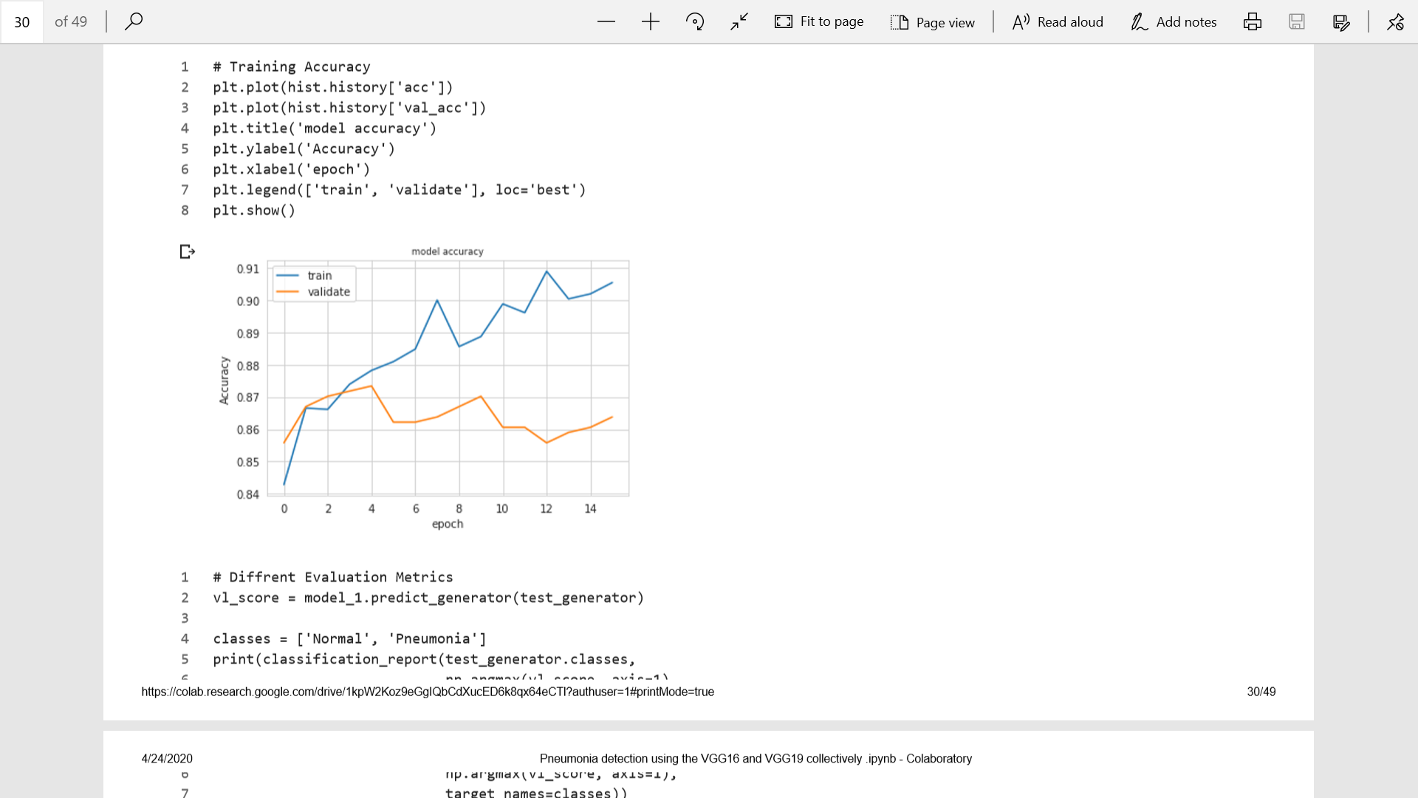

The graphs show that the validation and the training accuracy are equal in the phase of the 1-3 epochs, then the drastic changes are seen in the accuracy of the validation and training data. The validation for training data tends to increase up to 91% but the validation accuracy increases to 87 % during the time of four epochs, but then decrease and settle to 86 % up to the completion of the 20 epochs.

### 5.2.6) Model Evaluation

The model performs collectively well in analyzing the medical image. The model gains the validation accuracy of 86% which is satisfactory. But this project is not only focus on the accuracy of the model but also require the high precision level. Because the project is very sensitive. Accuracy is measure as the total number of the classification model had performed but the precision is said to be how much the model correctly classified the images according to the class.

The precision is measured as the ratio of the true positive by Total true positive (true positive + false positive). The precision for the class Normal is 82% and Pneumonia is 90 %. Here we can evaluate this model as one of the precise models comparatively because the important of precisely classifying the pneumonia images is more than normal images.

In the real-life scenario when the patient is diagnosed as pneumonia although patient doesn’t show the symptoms then the patient could reconfirm the diagnosed report but if the patient is said to have no pneumonia even there are symptoms then the life of the patient is at risk. So, achieving the precision level in the pneumonia is quite important. Even the required precision level is as much as high as possible here the precision level is higher than the normal which is satisfactory. Following image shows the model evaluation by calculating the precision, recall, f1-score:

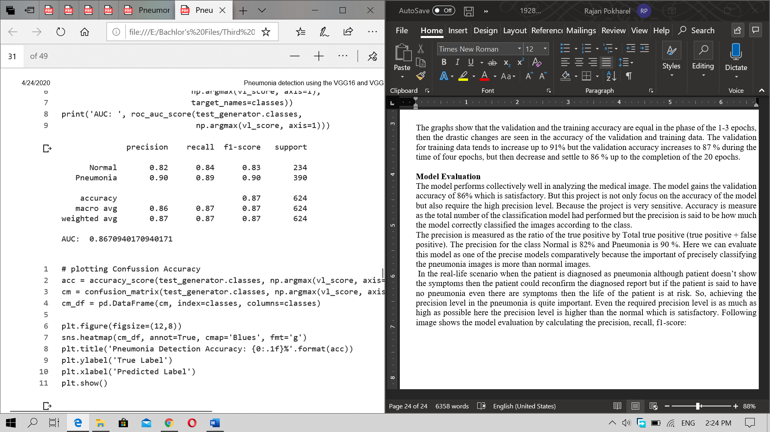

Figure 21 Model Evaluation

We can also evaluate our model based on the correct classes predicted by our model with the help of the confusion matrix. The confusion matrix shows the number of the actual classes and predicted classes by the model. Below is the confusion matrix for the model that is created. Out of the total 234 normal classes classified by the model, 197 were correctly classified as the normal but 37 were classified as the infected one. Similarly, out of 390 classifications done in the pneumonia samples 348 were correctly classified as the pneumonia and 42 were classified as the normal. Here the correct classification rate of the Pneumonia class is higher than the Normal class. So, the model is quite good as classifying the pneumonia images which is the most important in the precise projects.

### 5.2.7) Images predictions:

For the prediction of the image the model was given first the Normal images. Out of the 8 images given from the validation folder 7 were classified as pneumonia as expected because the false classification of the normal image is high and 1 was correctly classified as Normal.

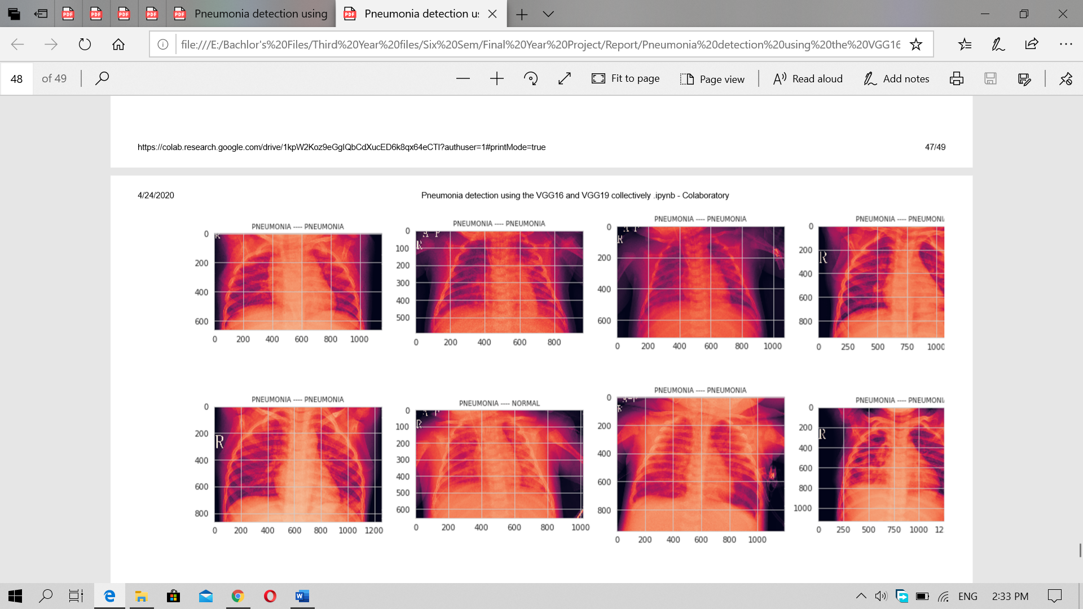

Figure 22 Normal Image Classification

But for classification of Pneumonia the model had successfully classify 7/8 images as pneumonia because of the model precision high for the pneumonia.

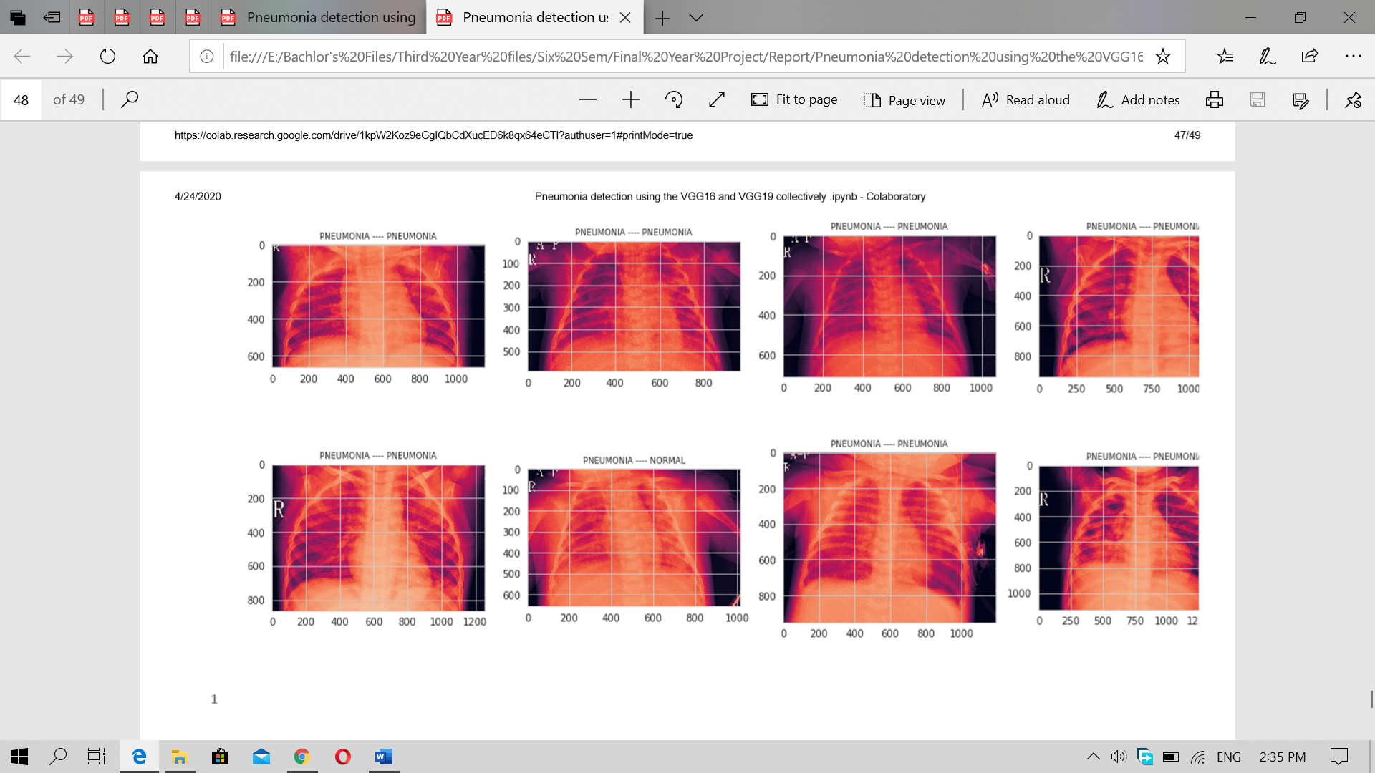

Figure 23 Pneumonia Image Classification

### 5.2.8) Model 2 creation

Although the model is performing well in classification of the disease but most of the Normal image is classified as the Pneumonia. The behavior of the model is shown as the over fitting which means the model is biased in the side of the Normal image and is classifying the Normal images as the pneumonia as it had learned Pneumonia well. To check this model’s performance with other kinds of the model made using the other techniques. Another model was made by using the inceptionV3. Keeping all the parameter same and the dataset is also same the model was developed. The preprocessing is also done as the same for the both models. The model is then compiled by altering the last layer with our layer that was created during the development of the VGG19 model. Same layer with same dense number is applied in this model also.

After compiling the model using the Adam optimizer then the model was fit with the training dataset which have the batch size of the train generator. But the model was given the step per epoch as 200 for 100 epochs. The validation step was set for the validation generator. After training the model for 100 epochs then the model was evaluated.

### 5.2.9) Model Evaluation

The model gained the validation accuracy of over 70% only. The model was performing well in the training accuracy of over 90 %. The model gained the precision score of 100% for the Pneumonia class and 50 percent for the Normal class. Here the model is fit for analyzing the x-ray image. Following picture shows the F1 score, precision and accuracy of the Model 2. Here the 0 represent the Pneumonia class and 1 as the Normal class.

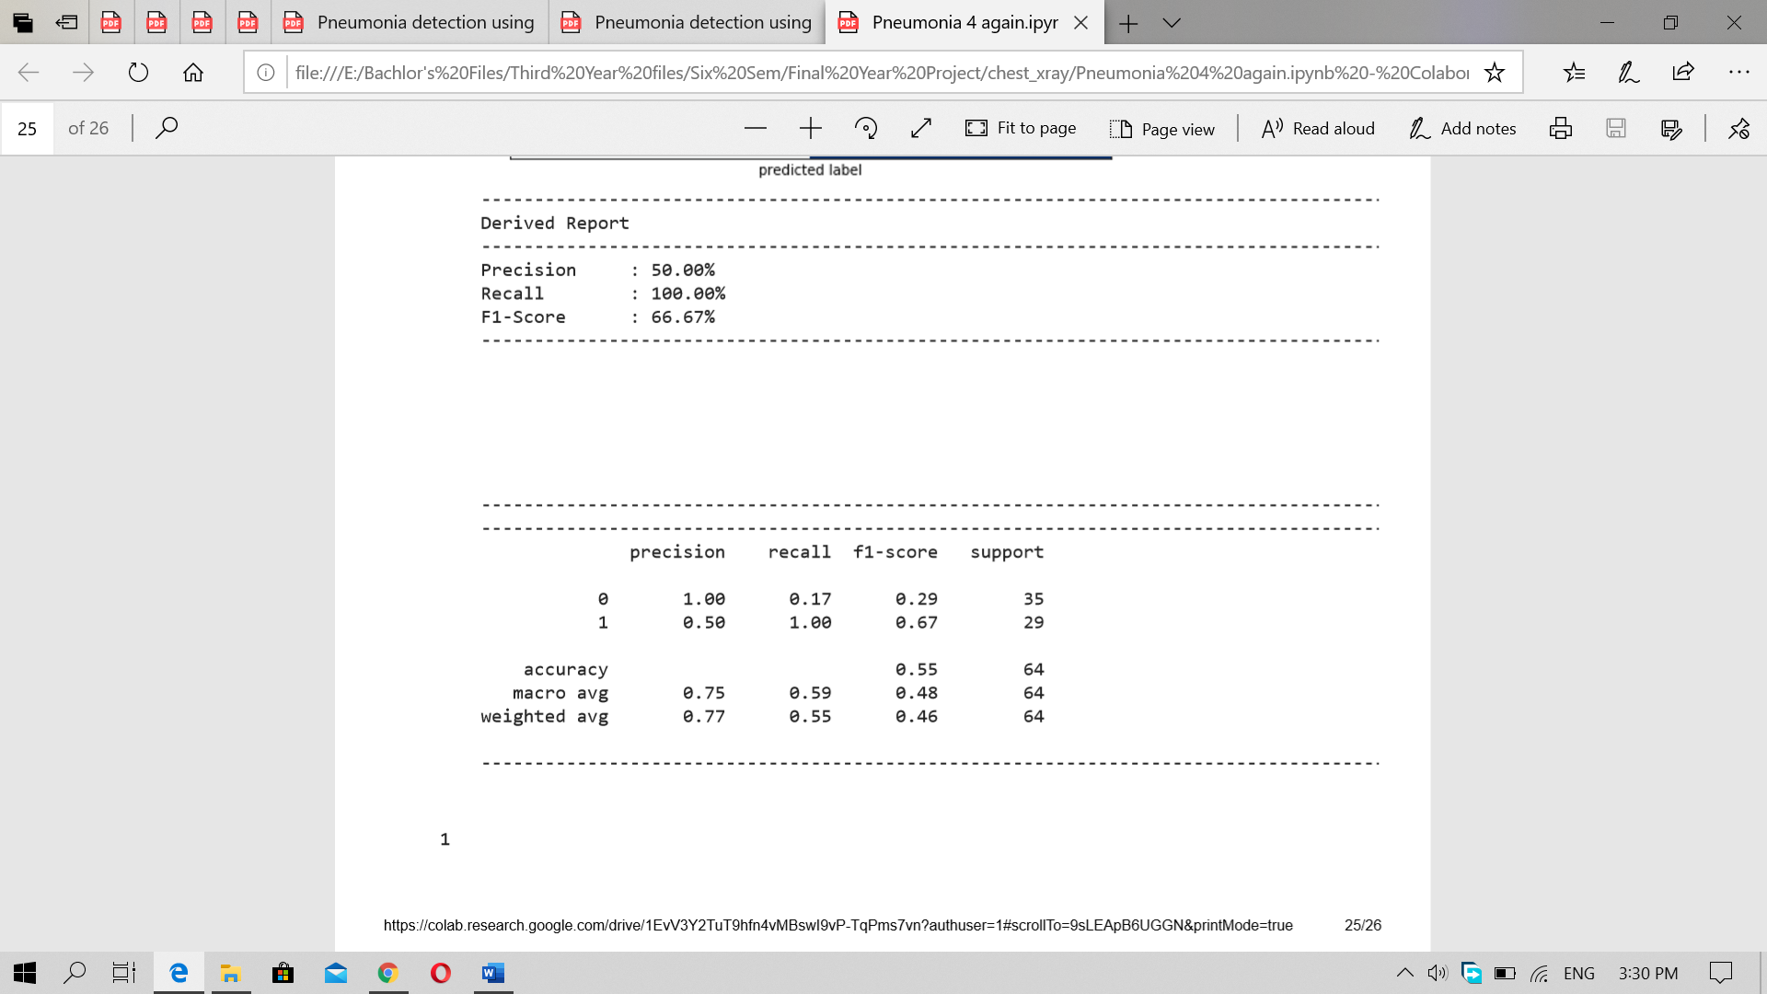

Figure 24Model 2 Evaluation

Here the class Pneumonia gained the 100% precision but weather the precision and can classify all the images of the pneumonia class as pneumonia correctly which could be seen from the below confusion matrix.

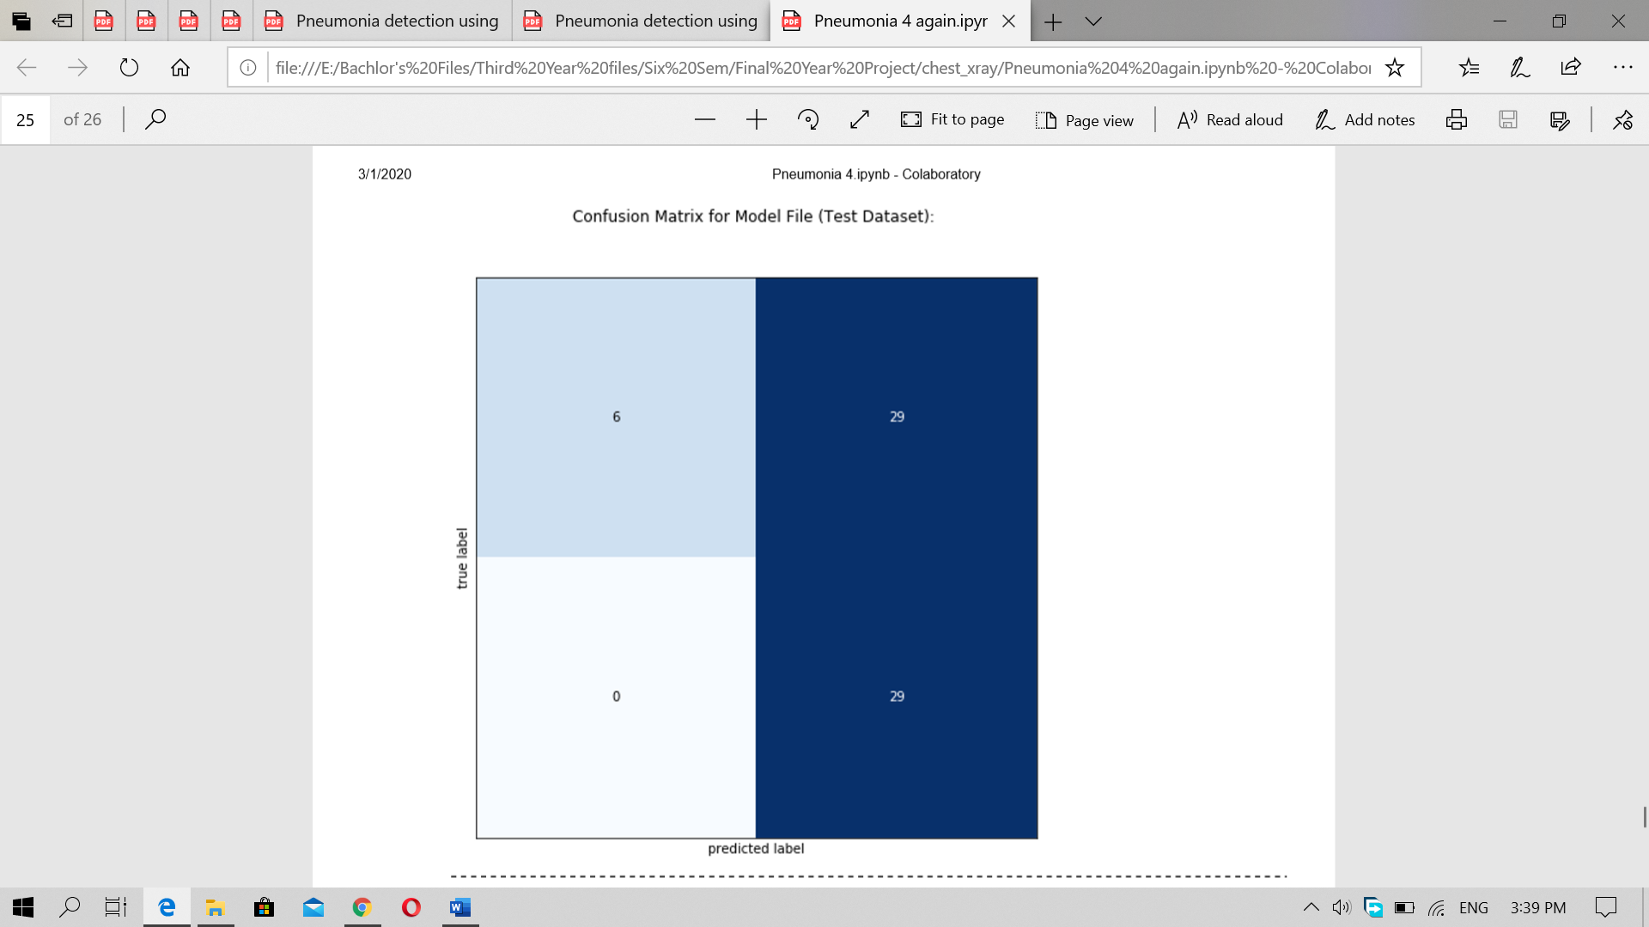

Figure 25 Confusion matrix for Model 2

Here the model successfully classified 29 images of the pneumonia class as pneumonia. But out of 35 normal images it only classifies 6 as the normal and 29 as the pneumonia. Here the model is seen well in classification for pneumonia also. But after the prediction is done in the validation set of the model classify most of the normal images as the pneumonia and classify the pneumonia image as normal. But according to the above report the model should classify all the pneumonia images as the pneumonia. This is where the conclusion could be drawn that the model could perform well in the training data but cannot perform well in the validation data which is not given to the model during the training time. So, the model isn’t well enough than the previous model made by using the VGG 19. Following shows the classification done in the validation data.

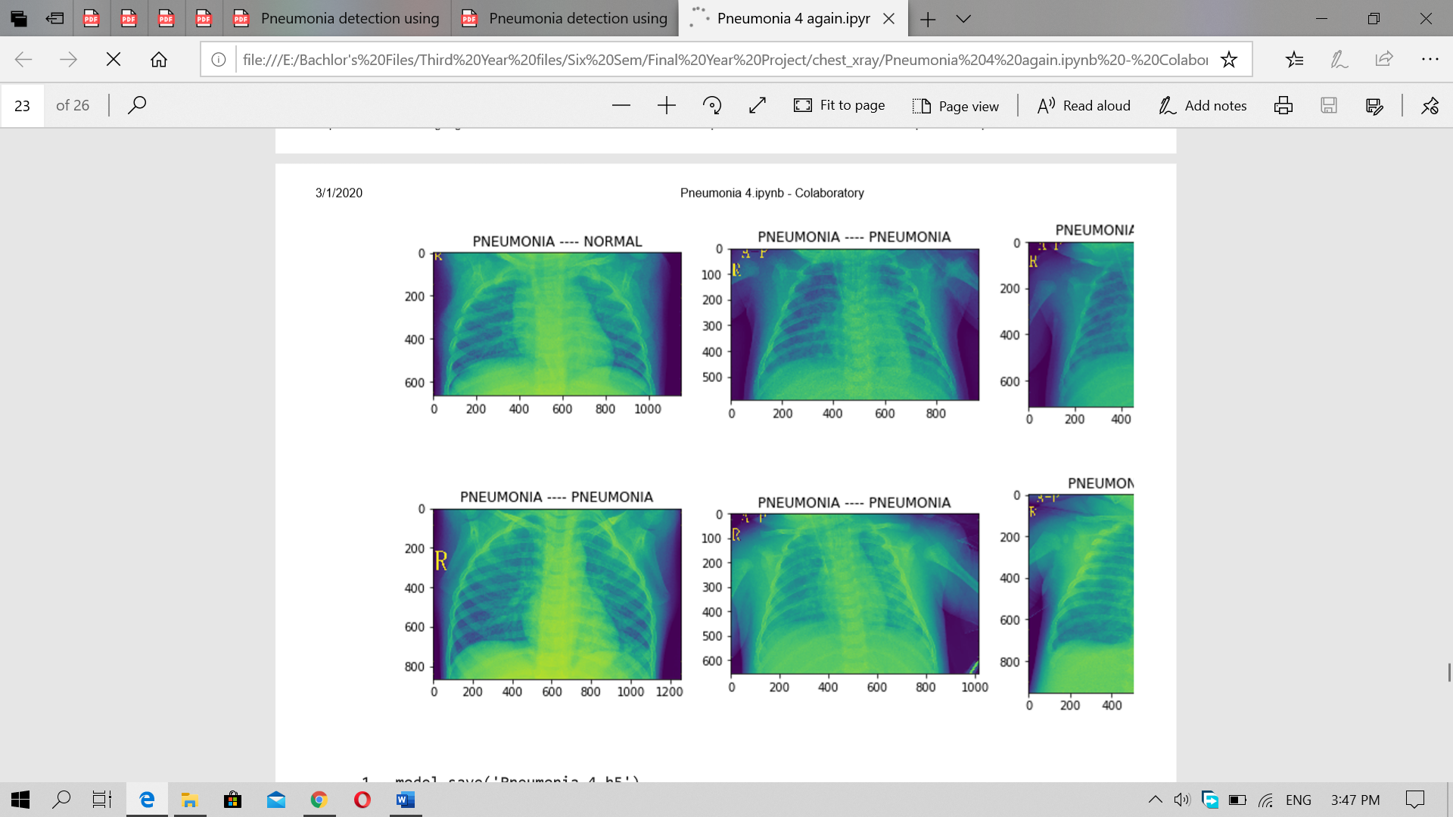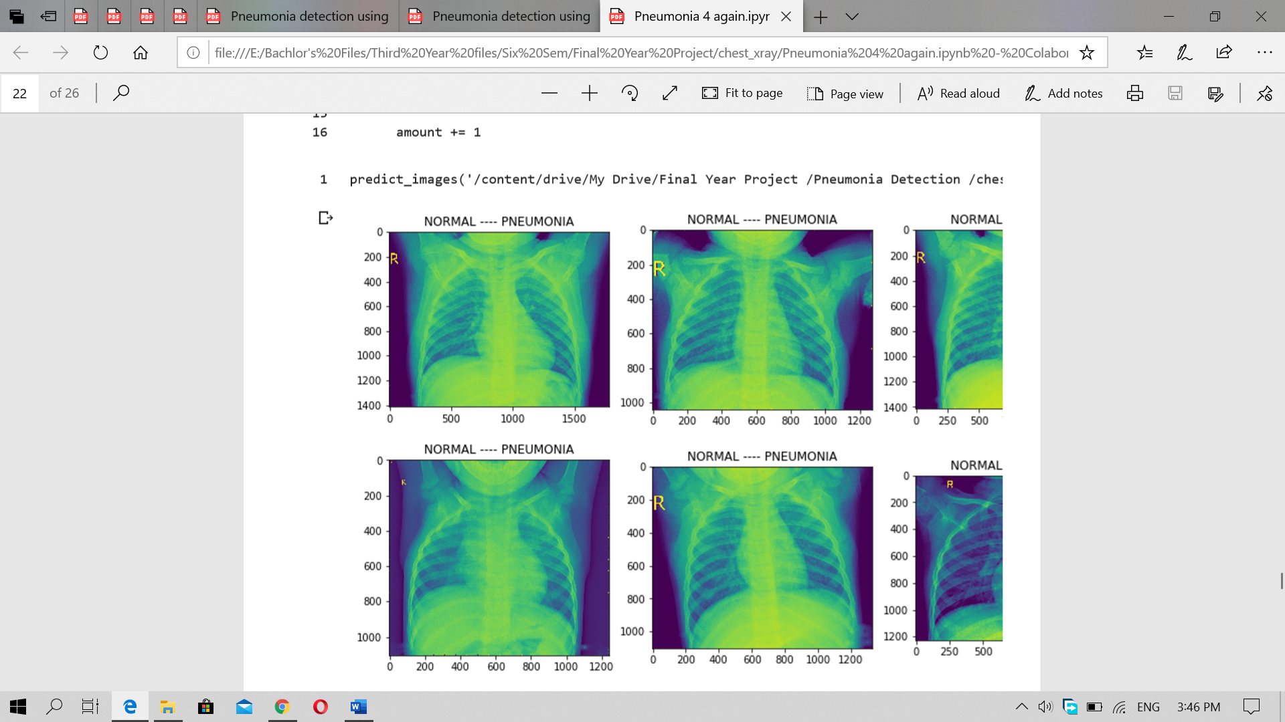

Figure 26 Pneumonia image classification for model 2

Figure 27 Normal Image classification for model 2

After analyzing both model the model made by using the VGG 19 is better than the model developed by the using the inception V3. Although there are many cases reported in the research that inception V3 is better than VGG 19 but with the dataset using in this project and data processing done in this project the VGG 19 is better than the inception v 3 in this case. The model could be made better by altering the last layers neurons, activation function used and by adding even more better layer in the inception V 3. Also, the data preprocessing could be done differently that could match the model structure of the inception V 3 even more and could produce the better result.

# Answering the Academic questions through the research and findings

The artificial intelligence was able to predict the images successfully. The images that were used for training the models were the frontal images of the lungs only, the model have no access to the patients’ medical history. In the above researches different researchers had tried to figure out the answer that the AI can beat radiologist or not. Some had tried by providing the normal, pneumonia and along with other lugs disease x-rays while others had used the normal and pneumonia only. The overall goal of the researchers was to make the algorithms more intelligent for determining the pneumonia. While performing the research the model was able to predict up to over 90 % accurate in the seen training data. While in few of the models were only capable of predicting correct in the unseen images. This couldn’t be the real-life scenario. The images of the patient would be totally unseen and unsimilar form each other’s. Doctors use the other medical examination like the swab of the patient for determining the pneumonia. In some cases, the patient would experience the symptoms, but the report can be negative. In this case the AI claims no pneumonia, but the experience of the doctors suggests performing other tests like the Bronchoalveolar Lavage test. (Antoine, 2019) which could give the perfect result.

The AI could be used for analyzing the medical images for easiness of the medical persons. Like for separating the pneumonia and non-pneumonia images but cannot rely upon it for the analyzing. Although the development of the CheXNet claims to beat the radiologist the same process was tried to replicate by the other team which is mentioned in the literature review but failed. There aren’t the actual algorithms that are claimed to be perfect for classification of the medical images regards the researches can change the dataset and alter it during the preprocessing for better feature abstraction. The model which is developed in this research also can classify the images but is not accurate as shown in the model evaluation part. As two different model gave the different result it is quite unclear to confirm that one is more accurate that other. This couldn’t be used for analyzing actual in the hospitals but could be used for research purposes only. Determining weather, the images have the imperfection beyond normal isn’t enough. To prescribe medicine the doctors should know all the medical history of the patient for providing the side effect free medicines. The AI just can learn the feature patterns between two class and try to classify it without any other knowledge of the patients. If the AI gives pneumonia normal signal and the doctors claims it as normal the life of the patient could be ended.

So, with the above performed researches and the finding along with the models built in this project the AI could be used for the analyzing the images, but the investigation shouldn’t only relay upon AI. Doctors could use it for referencing purpose and investigate patients by knowing the symptoms and medical history also.

# Conclusion

With all the research and development of the model it can be concluded that the artificial intelligence could be used well in diagnosing the medical abnormalities in the human bodies. The main aim of the project was achieved by successfully classifying the images of the patient having the Pneumonia and Non- Pneumonia. Though the developed model cannot be used clinically the researches could be conducted further on it for improving the model precision, accuracy and the classification as well as the feature abstraction capacity. The Deep learning method could be optimized well for performing the medical image segmentation. The model used in this project is VGG 19 which is customized for achieving the desired classification, but the own model development could be even better for abstracting the features of the images properly.

# **Critical** Evaluation

The evaluation of the whole project could be divided into the major three part. Final report, Software produced and finding from the project conducted. The details evaluation is mentioned below.

* 1. Final report

The final report is the collection of all the steps and procedure that are taken during the development and the completion of the whole project. The report is initially used for the academic purpose which contains the structured guideline format. The report was finished after parallelly with the development of the software or the artifact. The report consists of the literature review which is written referencing the similar types of the projects conducted along with the comparison of the projects is done. The report also features all the processes for developing of the system however one couldn’t build the similar system unless someone basic background knowledge is acquired. The supporting document provides basic background knowledge, but the experience isn’t allocated by the report. This report could only provide details information about system and its development. Due to word constraint many information couldn’t be addresses in the report like traying developing different algorithms their codes etc. but this report contains the all the need information that should be gained for understanding this system. One shouldn’t aspect the report to provide all details information about the machine learning and deep learning.

* 1. Software

The software build is the pneumonia detection using the machine learning processes. It is then integrated into the web app for easiness. The software shouldn’t be used for the commercial purpose in the medical field. It can identify the pneumonia and non-pneumonia but due to the accuracy and precision it shouldn’t be used widely. The software is done for research purpose to find weather the image classification could be great for helping the medical image analysis or not. The software could be made even more interactive with using the tools that could figure out the actual impacted part of lungs along with the classification label. The initial goal was to develop the label which could also shows the percentage of the likely to be the disease but due to some technical constraint the goa wasn’t achieved. However, the software gives the basic user experience for using the classification model in more friendly and understandable way.

* 1. Findings

During the completion of the project there are many findings discovered like the disease could be only abstracted from the dataset which contains the number of disease images, the heat map could provide the impacted view of the images due to diseases etc. the main aim of figuring out the academic question weather the deep learning could analyze the medical or not is figured out and yes the deep learning could analyze the medical image well. But the question of analyzing better than the professionals couldn’t be addressed due to the ack of the Realtime professionals. Though one of the literature review paper claims to beat the radiologist, another paper where same process is tried to replicate couldn’t performed as the same way the original paper performed. This might arise question for AI being more intelligent than the human being.

The critical evaluation is doe based on the expected things from the related title with comparing to the achievement during the project completion.

# References

AbhayDonthi, A., n.d. *Detecting Pneumonia with Convolutional Neural networks,* Colombia: University of North Corolina.

Antin, B., 2017. *Detecting Pneumonia in Chest X-Rays with Supervised Learning,* California: Stanford Univeristy .

Antoine, M., 2019. *Bronchoalveolar Lavage.* [Online]   
Available at: https://www.ncbi.nlm.nih.gov/books/NBK430762/  
[Accessed 8 5 2020].

Antoni Torres, N. L., 2016. Laboratory diagnosis of pneumonia in the molecular age. *European Respiratory Journal,* 48(0.1183/13993003.01144-2016), pp. 1764-1778.

J.Melendez, G., 2015. Anovelmultipleinstance learning-based approach to computer-aided. *IEEE Transactions on Medical Imaging,,* 34(1), pp. 179-192.

Jain, V., 2020. *Pneumonia Pathology,* s.l.: StatPearls Publishing .

Kadam, K., 2019. Deep Learning Approach For Prediction Of Pneumonia. *INTERNATIONAL JOURNAL OF SCIENTIFIC & TECHNOLOGY RESEARCH ,* 8(10).

Kang, N., 2017. *Introducing Deep Learning and Neural Networks — Deep Learning for Rookies (1).* [Online]   
Available at: https://towardsdatascience.com/introducing-deep-learning-and-neural-networks-deep-learning-for-rookies-1-bd68f9cf5883  
[Accessed 5 5 2020].

Koehrsen, W., 2018. *Beyond Accuracy: Precision and Recall.* [Online]   
Available at: https://towardsdatascience.com/beyond-accuracy-precision-and-recall-3da06bea9f6c  
[Accessed 5 5 2020].

Lotz, M., 2018. *Waterfall vs. Agile: Which is the Right Development Methodology for Your Project?.* [Online]   
Available at: https://www.seguetech.com/waterfall-vs-agile-methodology/  
[Accessed 15 5 2020].

Mortensen, E. M., 2002. *10.4103/0971-6203.58777,* s.l.: Arch intern Med.

Narkhede, S., 2018. *Understanding Confusion Matrix.* [Online]   
Available at: https://towardsdatascience.com/understanding-confusion-matrix-a9ad42dcfd62  
[Accessed 15 5 2020].

Pandey, P., 2019. *Data Preprocessing : Concepts.* [Online]   
Available at: https://towardsdatascience.com/data-preprocessing-concepts-fa946d11c825  
[Accessed 8 5 2020].

Pranav Rajpurka, A. Y. N., 2017. *CheXNet: Radiologist-Level Pneumonia Detection on Chest X-Rays with Deep Learning,* California : StandfodML Group.

Sacolick, I., 2020. *What is agile methodology? Modern software development explained.* [Online]   
Available at: https://www.infoworld.com/article/3237508/what-is-agile-methodology-modern-software-development-explained.html  
[Accessed 15 5 2020].

Saha, S., 2018. *A Comprehensive Guide to Convolutional Neural Networks — the ELI5 way.* [Online]   
Available at: https://towardsdatascience.com/a-comprehensive-guide-to-convolutional-neural-networks-the-eli5-way-3bd2b1164a53  
[Accessed 11 5 2020].

saxena, S., 2018. *Recall vs Precision.* [Online]   
Available at: https://towardsdatascience.com/precision-vs-recall-386cf9f89488  
[Accessed 15 5 2020].

Sharma, N., 2010. Automated medical image segmentation techniques. *Journal of Medical Physics ,* Issue 10.4103/0971-6203.58777, pp. 3-14.

Stephe, O., 2019. An Efficient Deep Learning Approach to Pneumonia Classification in Healthcare. *Hindawi,* 10(1155), p. 7.

Thomas, C., 2019. *An introduction to Convolutional Neural Networks.* [Online]   
Available at: https://towardsdatascience.com/an-introduction-to-convolutional-neural-networks-eb0b60b58fd7  
[Accessed 15 5 2020].

World Health Organization , 2019. *Pneumonia,* s.l.: World Health Organization .

# Appendix

**System Requirement Specification Document**

This SRS is made for showing the requirement for the system build for analyzing the medical image. It is the documentation view of the system which analyze the x-ray image uploaded by the user. It serves as the solution for the tedious and the complex analysis of the x-ray.

#### ***Intended Audience and Intended Use***

This SRS would be used during the system development period. It could be used by the system developer and the tester and other contributor in the project. It could also be used for gaining the system information.

**Product Scope**

The software is made for analyzing the medical images uploaded by user. Its main aim is to make the diagnosis of the pneumonia more precisely and accurately. It makes the tedious works of the radiologist or a doctor of diagnosing the pneumonia easier. The actual goal of the product is to classify the pneumonia and non-pneumonia image.

**Possible risks**

The application is developed using the artificial intelligence and machine learning. It isn’t the 100% correct and do not interoperate the disease well like of the doctors. The main risk could be the wrong diagnosis of the disease by the system. As, the system is built using only the dataset of the x ray images it could fail to interoperate the disease medication which is done by the doctors.

**System Overview**

The system is made for analyzing the medical x-rays of the patient. It is the Web application that runs in the localhost <http://127.0.0.1:5000/> and analyze the images for diagnosis. The system is made

This application is built for the medical personnel who have the knowledge about the disease diagnosis and the treatment, who could use the system for analyzing the images.

The system is made by using the trainable algorithms that are already presented in the ecosystem that are used for image classifications.

**User**

The main user of the system are the medical personnel who are willing to analyze the x-rays and diagnose the disease.

**Assumptions and Dependencies**

Although the system is made by artificial intelligence and machine learning there are certain constrains. The system which is made and included in the SRS document may not provide the expected result. The system is assumed to be used only for the research purpose not for the clinical propose.

The prediction is depended upon who well the machine learning algorithm is trained and can classify the images.

**Specific Requirements**

Following are the main requirements for the development of the system.

**Functional Requirements**

The user can upload the image and get the predictions. The system must have the machine learning model in it so that the prediction is used. The system must classify the images.

**External Interface Requirements**

Following are the external user interface included in the system.

* User

User uses the system who could be medical personnel.

* Hardware

Hardware is the local host running the software on it.

* Software

Software for this system is default web browser of the local host computer.

**System Features**

Following are the system features for the system.

* Upload feature
* Prediction feature

**Other Nonfunctional Requirements**

The system uses the machine learning algorithms for classification so the accuracy and precision of the algorithms should be more important. The system should be fast for analyzing the images and showing the prediction. The system shouldn’t be used by the nonprofessional for analyzing the images.